SHACKLETON EPIC EXPEDITION JANUARY – FEBRUARY 2013POST EXPEDITION REPORT
References:

Google Earth
Mapping: BAS (Misc) 12A and 12B Scale 1:200 000

INTRODUCTION

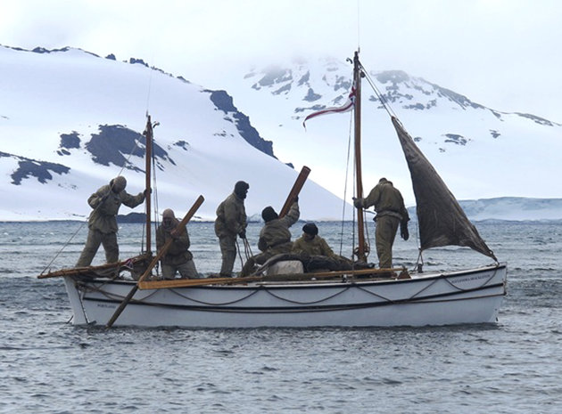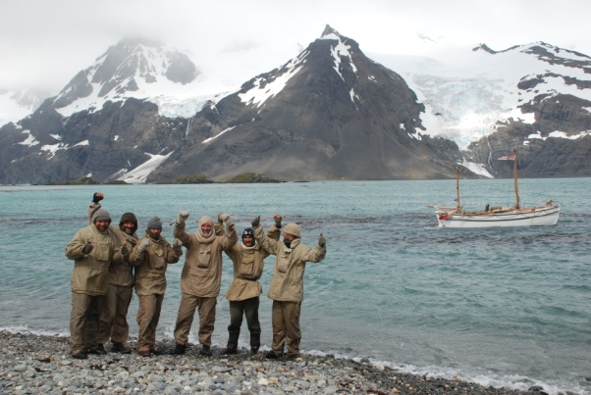
Pushing away from Elephant Island-23 Jan 2013 Arriving King Haakon Bay-03 Feb 2013

1. The Shackleton Epic expedition set off from Elephant Island four days behind schedule due to poor weather and sea state on 23 January 2013.After twelve very tough days at sea, the six man team became the first team to successfully and completely unsupported arrive in King Haakon bay. This journey was completed using only celestial navigation techniques in an almost exact replica boat and in vintage clothing.

2. On arrival at King Haakon bay (Peggotty Bluff), the team immediately began preparations to begin the crossing of South Georgia. Only three of the team were to stay in vintage equipment, while the other three were to utilise modern clothing and equipment and act as a safety team. After poor weather for four days, a depleted team set off at around 1900hrs on 07 Feb 13. At around midnight on 07 Feb 13 one of the camera team needed to be extracted due to serious leg trouble, this left team stuck in serious bad weather once more and unable to move for two days. At around 1700 hrs on 10 Feb 13, Tim Jarvis, Barry Gray and Paul Larsen set off once more from Shackleton Gap on the journey across South Georgia.

3. At 2245 hrs on 11 Feb 13, the team of three walked into Stromness harbour becoming the first team to complete the double of crossing the Ocean from Elephant Island to South Georgia, then continuing over the mountain range to Stromness, all in original clothing and using only equipment available in 1916.

EXPEDITION OBJECTIVES

4. The Shackleton Expedition had several major objectives it intended to achieve during the period of the expedition and beyond into the future:

- To successfully sail the closest ever built replica boat to the James Caird from Elephant Island to King Haakon Bay on South Georgia.
- To walk to route across the mountain range of South Georgia from King Haakon bay to Stromness.
- To complete the entire journey unsupported.
- To use only equipment, clothing and technology that was available to Shackleton in 1916.
- To highlight where possible the environmental changes in 100 years and to assist in the promotion of conservation in South Georgia, highlighting the difficulties faced by the authorities there and why.

EXPEDITION IN DETAIL

5. On completion of the sea journey in the replica James Caird (Alexandra Shackleton), the six man team consisting Tim Jarvis (Expedition Leader), Barry Gray (Mountaineer), Nick Bubb (Skipper), Paul Larsen (Navigator), Ed Wardle (Camera man) and Seb Coulthard (Boson) went in to forced rest and recuperation for a period of at least 48 hours before setting off across South Georgia. In order for the safety plan to work the team re-rolled into its new formation. Tim Jarvis, Barry Gray and Ed Wardle remained in a unsupported role in the same clothing etc. on the beach at Peggotty Bluff while the other three members returned to the support vessel in order to be equipped fully in modern mountaineering gear and rested as best as possible. It was also at this point, two members of the film crew prepared themselves for the crossing of South Georgia.

6. Once preparations had been made and all groups were ready in all respects for the crossing, we just had to pick a good weather window and time to start. This timing had to be picked at least twelve hours in advance to allow our support boat the opportunity to sail to the North side of South Georgia in order to be able to best support us in the event of a serious injury. Things did not go to plan at this stage with some extremely serious weather holding us back for a period of almost four days. During this frustrating period, some of the crew members had succumbed to quite serious trench foot injuries from the boat journey. This injury does take time to develop and can be very serious if ignored and not treated correctly. To carry on with this injury could have meant long term or permanent nerve damage. Nick Bubb and Ed Wardle had to leave the expedition at this stage due to this injury. This was a big blow not just to them but to the whole team.

7. On the morning of 07 Feb 13 a decision was made to set off from Peggotty Bluff around 2200 hrs that evening and the support boat left the crossing team behind in order for it to move itself around to the North side of the island and wait in Possession Bay. The crossing team set off from Peggotty Bluff at around 2200 hrs on 07 Feb having had confirmation the support vessel was in place. The team consisted of Tim Jarvis and Barry Gray in full authentic equipment, Paul Larsen and Seb Coulthard in full modern equipment and Joe French with Si Wagen as the camera team.

8. The weather as we set off was good, clear visibility, little wind with temperatures sitting at around 2 degrees Celsius. Good progress was made over rock terrain for about two kilometers up to the start of the glacier on the Shackleton Gap. At this point the whole team fitted crampons and began to use ice axes with the exception of Tim and Barry who had screws driven through the soles of their boots. There was no need to rope up at this stage; the glacier was solid ice and all obstacles were clearly visible with nothing technical to overcome. The route taken up the Shackleton gap was in an Easterly direction then swinging SE to pass the Southern side of the large Nunatak 54 08 38.29S – 37 11 47.51W towards the Murray Snowfield. It was at the point of transition between the Shackleton Gap and Murray snowfield that the team roped together in their three distinct groups (although very stable and good snow conditions, the Murray snow field is a heavily crevassed glacier with many hidden dangers).

9. At around midnight on 07 Feb, Simon Wagen of the film crew informed the team that he was in severe pain and had lost most of the feeling in his left leg; he was clearly not in a position to continue. The call was made by Barry Gray to extract him immediately via the pre-arranged plan and route. The safety plan in place ensured that all team members stayed together at all times. The nearest extraction was at the head of Possession bay so we immediately headed in a generally North East direction towards this area whilst informing the support vessel of our intentions. During the descent the weather became dramatically worse, winds picked up and the rain began to pour quite heavily. The team stopped and established a camp around 54 07 47.14S – 37 10 46.72W, at first light two members of the team escorted Simon to the support vessel then returned to camp location. The morning of 08 Feb proved to be pretty awful with winds in access of 85 knots and with no immediate sign of it abating, the call was made for the support element to make their way to the shelter of the support vessel, leaving Tim and Barry on the Glacier. The plan was then to wait for another weather window.

10. With the now depleted film crew, a decision was made not to now film the crossing but to get those crossing to get as much footage as they could, at the same time, Seb Coulthard had now developed extreme swelling in his feet due to trench foot and pulled out. At midday on 10 Feb 13, the decision was made to go for the crossing a second time, the weather was not great, poor visibility, still fairly strong wind but it was dry. Paul Larsen headed up from the support vessel and we headed off in a southerly direction back up the Shackleton Gap towards the Murray snowfield at around 1700 hrs.

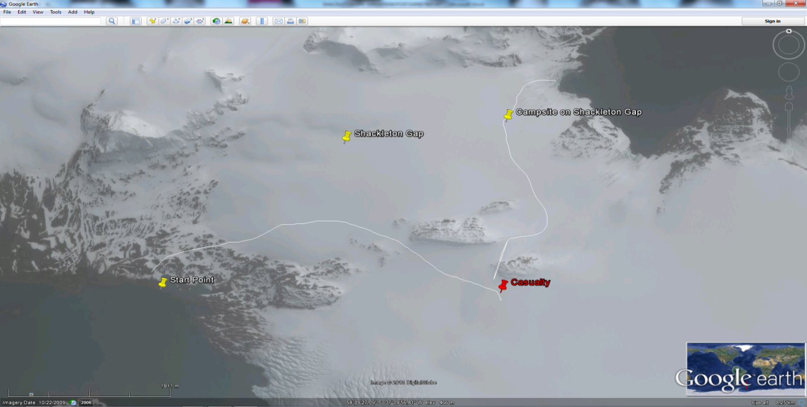
Route from start (Peggotty Bluff) to the casualty extraction point and route to meeting the Support Vessel.

11. The route back up onto the Murray Snowfield was very challenging, winds were high, there was zero visibility and we were breaking trail in the snow to ankle deep level. Due to only navigating via a prismatic compass, it became imperative that we switched direction back to an Easterly direction at the right point in order to ensure we were heading straight towards the Trident range. Walking too far or turning too soon would have made life extremely difficult.

12. As progress was made towards the Trident mountain range, the weather began to abate and at around 2200 the clouds cleared for the first time giving us all one of the most spectacular views ever seen. We were stood directly beneath the Tridents, with our crossing point being about 400m to our East. Conditions under foot were OK but hard going, we had only one or two drops into the crevasses below but only to just above the knee. (Point to note: conditions were perfect for skis)

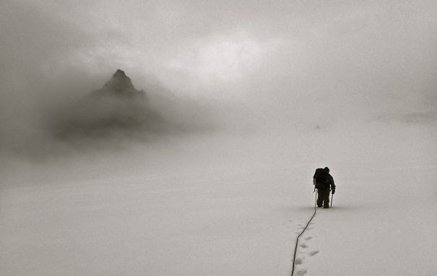 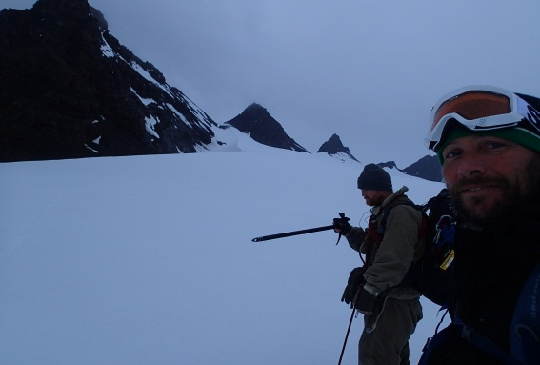 On Murray snowfield, first glimpse of Tridents Tridents in all their glory

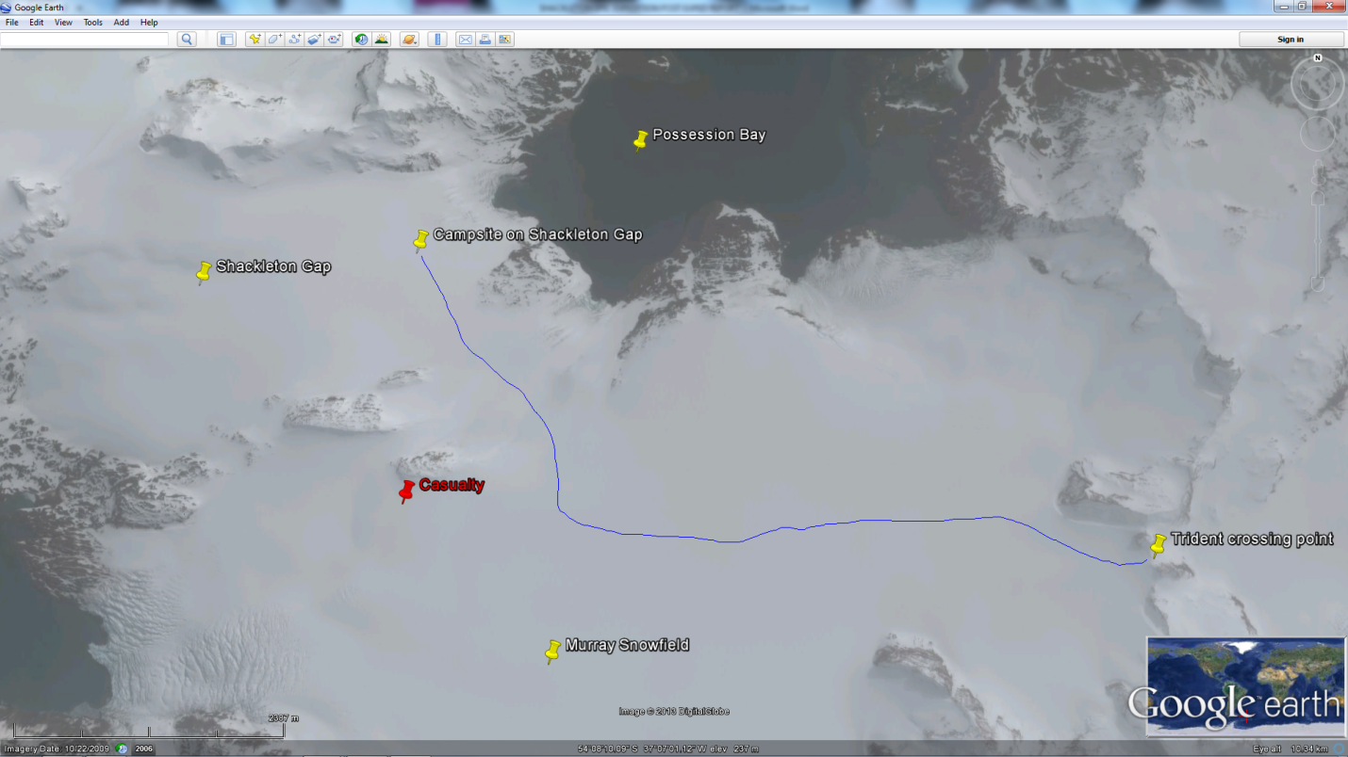
Blue line denotes route from Campsite on Shackleton gap to the crossing point of the Tridents

13. The Tridents have four possible crossing points in the form of saddles running North – South. From Shackletons and Worley’s accounts after the event, they tried them all from South to North, finally choosing a descent route at the most Northerly Saddle. Today, the best descent route without the use of ropes to abseil is the second saddle from the North (Note: This could change dependant on time of year) and the one you are most naturally drawn to as you approach. On arrival at this saddle the view below was clear and the route we had to take east could be seen all the way to Breakwind Ridge. The snow conditions on the decent were very stable and good foot placements could be made. Directly below us, due East was a very large opening in the slope and lots of exposed ice. This was quite simply avoided by traversing down the slope in a NE direction. After about 150ft of descent it was possible to switch back due East with a clear steady slope all the way to the glacier below. In true Shackleton style we descended the rest of the slope roped together sliding down on our backsides. The conditions were very stable and arresting a fall was very easy. This would be not advised in poor visibility as there is the odd large exposed rock, easily avoided in good visibility. This added a bit of safe controlled fun to the descent and saved time as the dark hours were rapidly approaching.

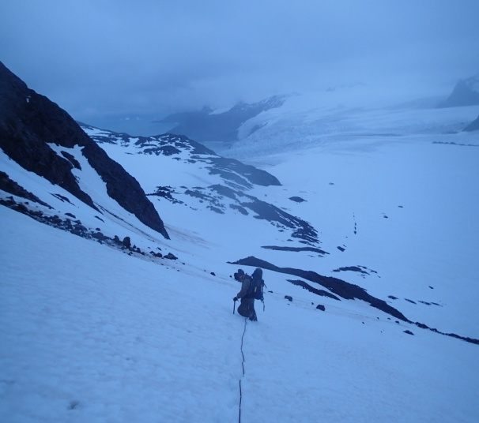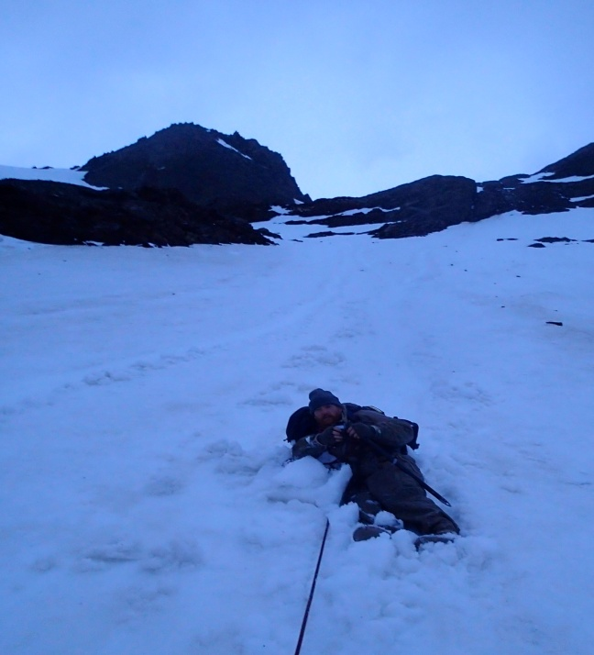
Looking down Trident descent heading NE At Base of Tridents after slide

14. Our route then continued in an Easterly direction across a relatively flat section of ice and snow with very little crevasse risk. The ground to our North swept down to Antarctic Bay which was clearly visible and to the south, large glaciers rise up to the mountain tops. Due to our now lack of ability to carry a serious injury to an extraction point on the coast, we decided not to move during the dark hours across the Crean glacier and we instead pitched camp for a few hours until first light. The campsite was almost like it was put there specifically for our stay. We walked into a small band of rock running N-S across our path, on the southern end of it was a perfectly formed circle of sheltered rock, this we believe to be what has become known as Crean camp.

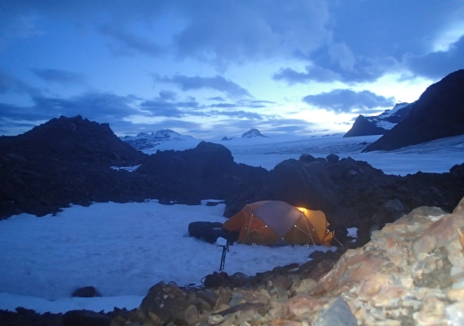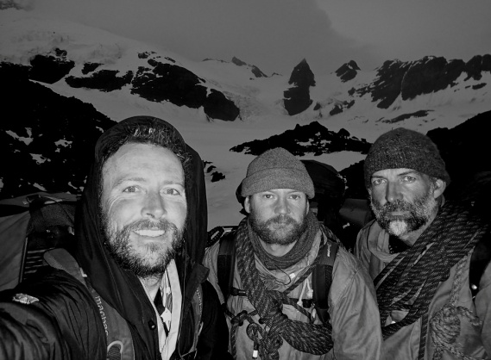
Descent route on Tridents
Crean Camp with Crean Glacier at top of picture. Looking back from Crean camp with Trident range
Behind us.

15. At first light we continued on route again in an Easterly direction. The visibility was very good with very little wind; temperatures were around 0 – 2 degrees Celsius. The route in clear visibility is very easy to follow keeping the large mountain spurs that run into the glaciers to the South. The route from the camp to the start of the Crean glacier was fairly straight forward but roping up together is essential, there were many covered crevasses with only thin snow bridges. The route was easy to negotiate due to being able to see the obstacles approaching and picking your route well in advance, in poor visibility this would be very difficult.

16. The Crean glacier was full of hazards if a poor choice of route is taken. In good visibility it is possible to start planning your route at least an hour prior to hitting it. At this time of year the glacier should be hit to the South side and fairly close to the Mountain spurs. There is no requirement to get stuck in amongst the huge exposed cliffs of ice in the centre of the glacier. Once you commit to this type of exposed glacier it can be very difficult to negotiate a safe route out as you lose all sense of direction very quickly.

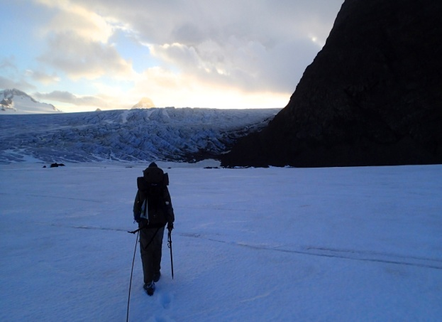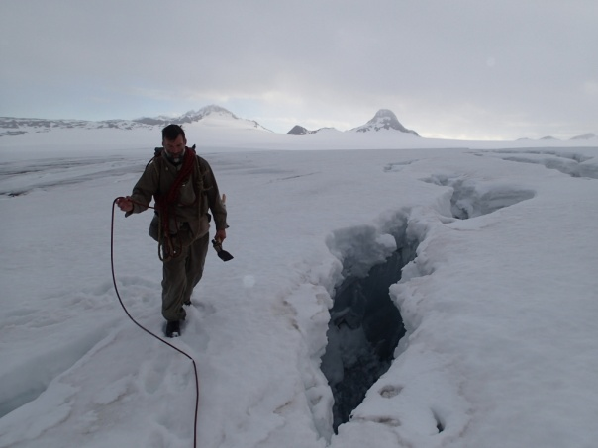
Approaching the Cean glacier Exposed crevasses on Crean Glacier (Note Tims
large carpenters adze)

17. The route chosen over the Crean glacier was passed with very little trouble. Once passed the large blocks of exposed ice you rise up to catch a glimpse of the rest of the route which is a very steady and gentle rise in an Easterly direction all the way to the start of the Fortuna Glacier. The conditions under foot were fairly good and stable, the snow was about ankle deep for the vast majority of this section.

18. The Fortuna glacier was crossed in a slight North Easterly direction and is now a steady downhill plod which took around 2 hours to cross on foot. This section would have been great on skis. The ground was flat and the snow ankle deep in parts but very firm on the surface in other places, it was constantly changing. The route over the Breakwind ridge was clearly visible as well as the route straight to Fortuna bay which Shackleton’s party took by mistake. The Fortuna glacier is a mass of hidden crevasses and must not be taken lightly, becoming complacent here is very easy. On two occasions our party experienced full crevasse falls with an individual hanging completely free in the air. Arresting crevasse falls was very easy as was extracting back out of the fall due to the excellent snow conditions. At this time of year the Fortuna glacier would have been best traversed on Skis, the conditions were extremely good for skis. This was obviously not an option for this team.

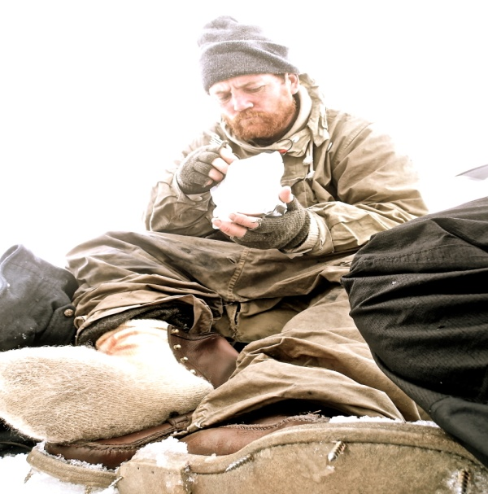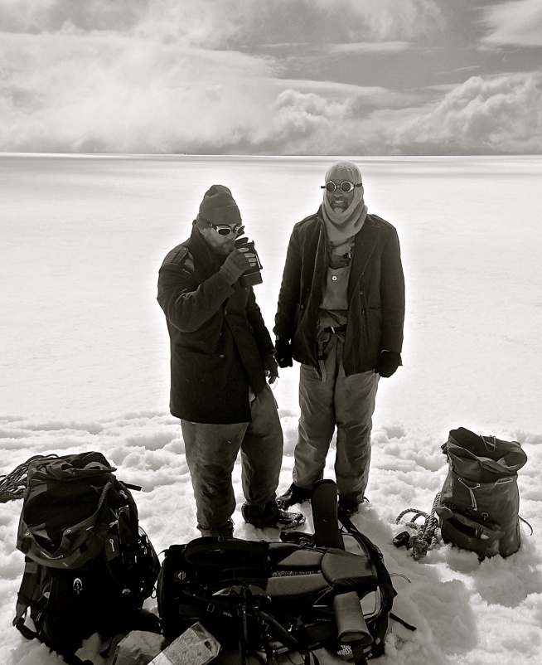
Taking a break between Crean and Fortuna. Tim and Barry taking a break.
(Note screws through soles of Barry’s boots)

19. At the end of the Fortuna glacier we swept round the North side of a large rock band to enter a large bowl which consisted of the main Breakwind ridge which was to be Shackleton’s final obstacle (or so he thought). In the South East corner of the bowl lays the point at which we crossed, described by the original expedition as looking like a missing tooth; it is the place you are also naturally drawn to as an obvious place to cross the ridge.

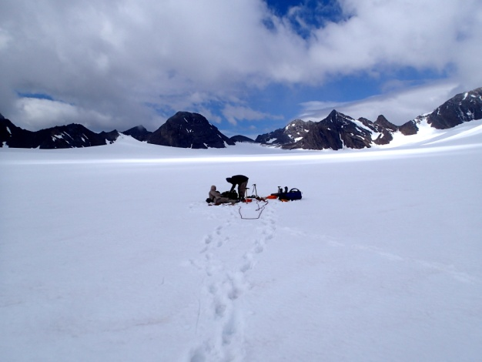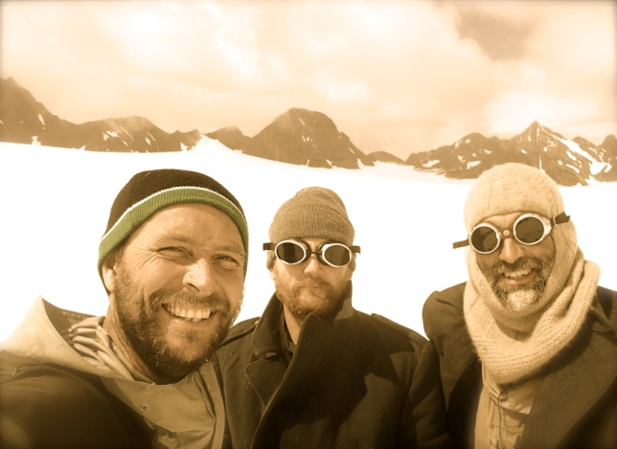
Crossing point on Breakwind ridge
Making a hot drink, Breakwind ridge behind. Paul (L), Baz(M) and Tim(R), in front of Breakwind ridge.

20. The route from Fortuna glacier to the crossing point of Breakwind ridge was in a South East direction and gradually uphill but nothing too severe. As you approach the saddle in which you cross, the slope does steepen but no more than 40 degrees. On reaching the saddle we were greeted by fantastic views down in to Fortuna bay and across to the final ridgeline that once past would see us descending into Stromness. The route down in to Fortuna bay at first glance appears to be a very straight forward gentle plod down, do not be fooled, this soon turns to a very steep snow, ice and tricky rocky descent, especially when fatigued. Not all modern expeditions choose to descend this route, some choose the next valley over to the South. On reading Shackleton’s and Worsley’s accounts, it is quite clear they took this descent route and found themselves having to rely heavily on the rope. For this reason it was the route we had to go down and found it equally challenging.

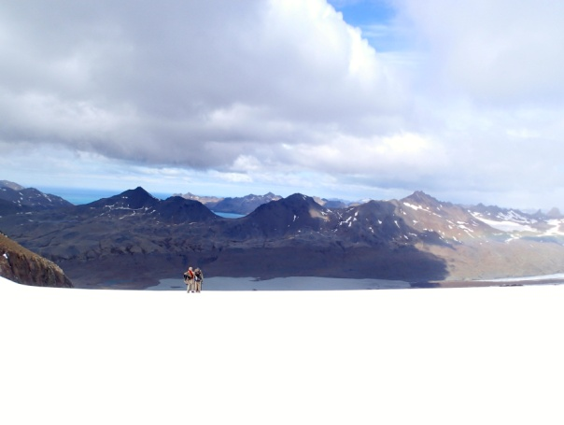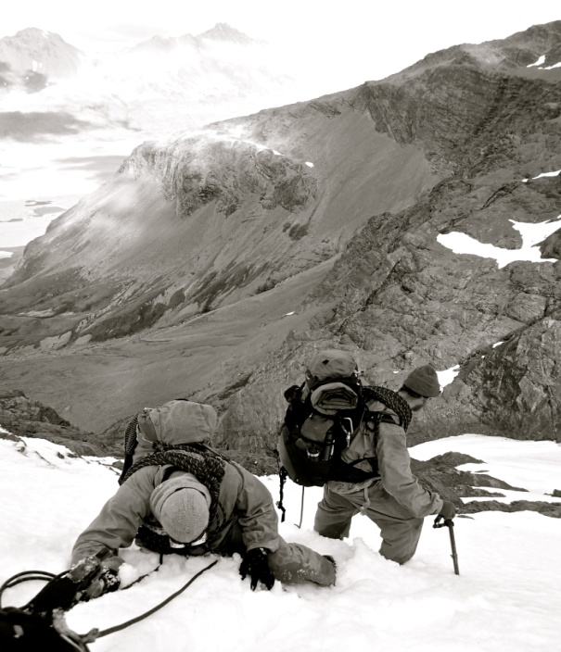
Stromness Harbour
On top of Breakwind, looking East to Stromness. A tricky descent in to Fortuna bay.

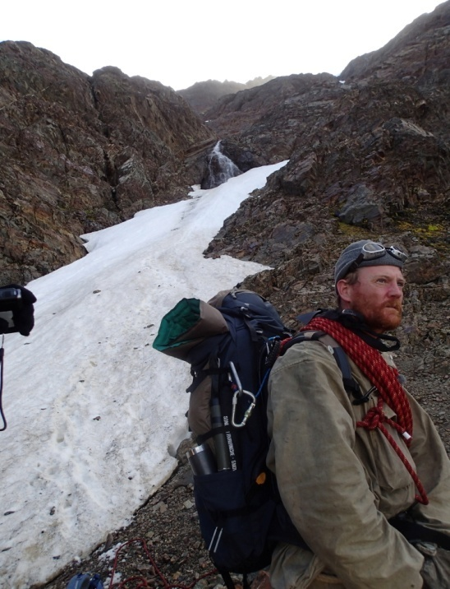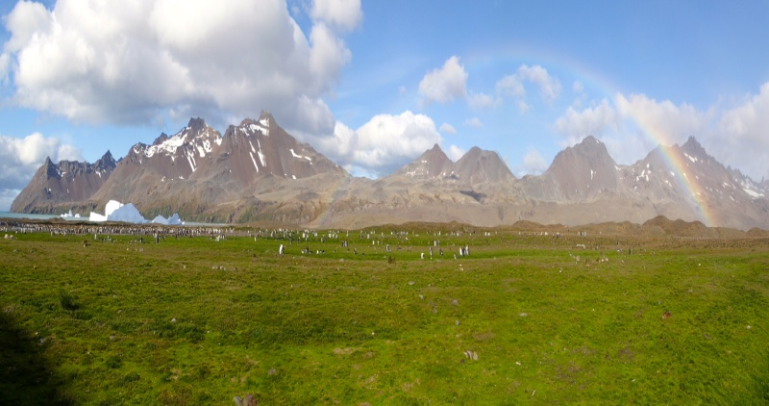
Final Climb to Stromness
A view up the descent route from Breakwind A beautiful and very welcome Fortuna bay.

21. The route from Fortuna bay was very straight forward and consisted of a walk along the beach through a very large Penguin colony and a few angry seals snapping at your ankles if you get too close. There was one small water obstacle, a gushing river heading out to see that did cause a little discussion as to whether it was safe to cross or not. The alternative was a hike back up the valley for about a kilometer so the risk was taken and five minutes later we all had very wet feet. We then set off up the final climb to the pass in which we crossed to drop into Stromness passing on the climb the iconic Crean Lake in which Shackleton attempted to cross and ended up to his waist in water when the icy surface gave way.

22. At the top of the climb we had the long awaited and spectacular view down to Stromness harbour and the old whaling station was clearly visible. We had made it finally. The descent down is again straight forward with the Southern side of the valley being the easiest and best route to the flat ground at its base. We were greeted again by quite a few angry seal at Stromness harbour who were not as pleased as we were that we had achieved what had been over five years work for Tim Jarvis. All the support crew and the rest of the team were there to greet us and welcome us over the finish line with some very nice tasting champagne.

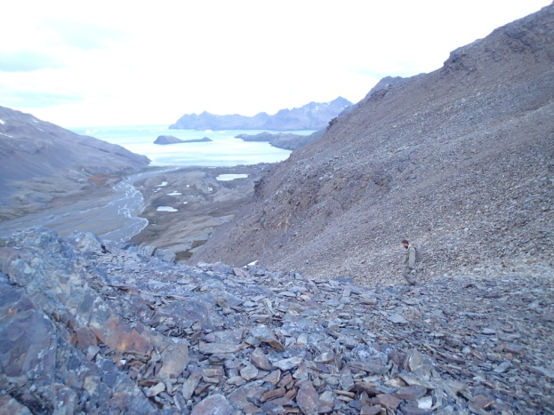 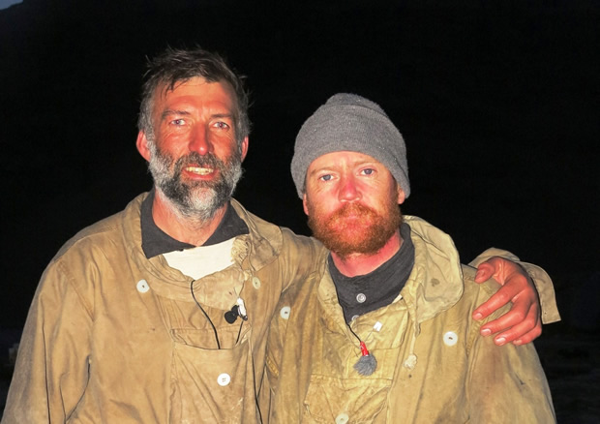 Walking down the final descent in to Stromness. Tim Jarvis and Barry Gray at the finish in Stromness.

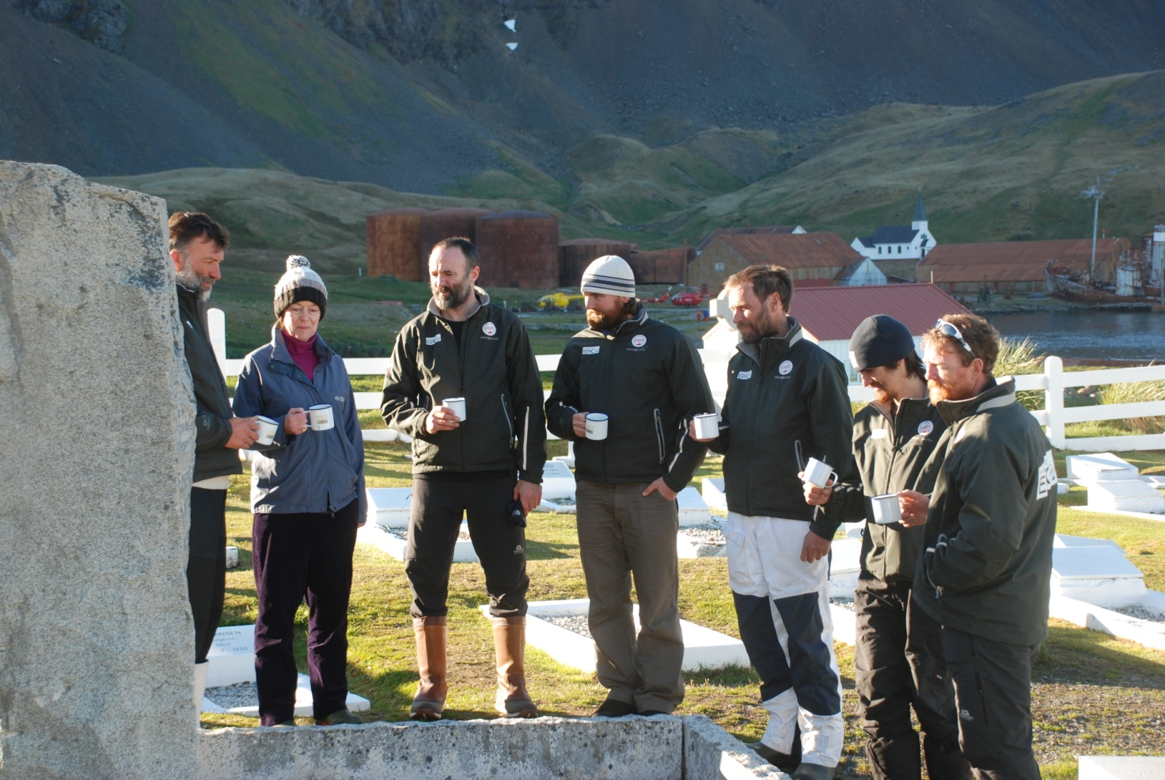
The team enjoy a toast of Shackleton Whiskey at the Grave of Sir Ernest Shackleton in Grytviken; it was a huge pleasure to be in the company of our Patron and Granddaughter of Ernest Shackleton, the Hon Alexandra Shackleton. In picture L-R, Tim Jarvis, Alexandra Shackleton, Ed Wardle, Nick Bubb, Paul Larsen, Seb Coulthard RN and Barry Gray.

SAFETY PLAN
23. The safety plan for this expedition was as robust as it could be given the unfortunate circumstances we found ourselves in. The plan was always to self help and extract over land to the nearest safe area of coastland. The Support boat Australis would then meet the team with the expedition Doctor who would then make the call as to the level of treatment required. The more people available on land the easier and safer an extraction would have been, we were therefore not as safe when we ended up with only three team members crossing as we would have been with the originally planned nine members, although you could argue that the more on the crossing the more likely an injury. The most obvious way to improve the safety plan would be to have helicopter support as this is not available in this very remote area with the exception of the SAR asset in the Falkland Islands, a two day flight away. In order to achieve this would be extremely expensive and would require a huge amount of financial backing, something this expedition just did not have.
24. The Shackleton route is not one that is technically challenging to the experienced mountaineer, one that is used to working on glaciers and the risks associated with them. The lack of a technical challenge can leave the door open for complacency and possibly encourage experienced mountaineers to attempt a crossing with individuals of an unsuitable nature. On foot it can be very tiring, the weather it extremely changeable, most notably the wind speeds and the visibility which can be extremely poor for very long periods of time. Anyone attempting this route as a leader must ensure that the team undertaking the challenge is fully conversant and very well practiced in all the techniques required and that they are equipped accordingly. The South Georgia authorities must be praised for the manner in which they are very robust with expeditions and this routine is strongly encouraged by this expedition.
25. In did turn out that our expedition did have to use its extraction plan and it worked very well. There was one man responsible for all decisions and that was final. All parties were extremely well briefed in the plan which left no room for Irish parliament or discussion on the hill. This was key to the overall control and accepted by the team.
ENVIRONMENTAL PLAN
26. The impact this expedition had on the environment was very minimal with our footprint being kept to a minimum at all times. All the rules laid down in the visitor to South Georgia guidelines were met, with great care being taken not to leave any sign we were there. All waste and rubbish was removed by the expedition and carried out on the support vessel as planned prior to the expedition. The wildlife encountered was respected at all times and our distance was always kept, which can actually be quite difficult in certain areas, Fortuna Bay for example. Tim Jarvis is very keen on ensuring that the environmental impact on South Georgia over the last 100 years by both man and global warming is highlighted in order that support for the SGSSI authorities is continued and to encourage the great job already being done.
27. Nothing unusual or out of place was sighted by the expedition. One of the big issues at the time we were there was the rat population, which was due for a complete cull. There were rat sightings in King Haakon bay, which were reported in detail to Pat Lurcock in Grytviken.

EXPEDITION APPLICATION AND PROCESSING

28. The expedition application process for South Georgia is very detailed, robust and thorough. All the information required by the authorities is readily accessible on their website and very clear to follow. For new visitors to South Georgia, the application process forces you to think clearly and understand just how remote and special this island is and it makes you ask all the right questions of your expedition. Millions of pounds are being spent on protecting South Georgia and many many hours of hard work have gone in to the projects surrounding its protection and for all the right reasons. It will only take one poorly led and planned expedition to spoil all this effort. This is completely unacceptable by the SGSSI authorities and in our expedition views, rightly so. Along with the robust and inquisitive nature of the authorities, we found the panel of experts to be patient, extremely flexible, supportive and available to advise us at any time. Our expedition did require a bending of the rules at certain times and these requirements were understood and accepted.

29. In the view of the Shackleton Epic expedition, our treatment throughout the entire planning of the expedition until the completion at Stromness was nothing but exemplary at all times. Many hard questions were asked of us on various occasions in which we knew we must find the correct answer or amend a procedure. South Georgia must be protected and looked after, this takes time, money and many years of hard work, we encourage the thorough nature of the expedition application process and back it all the way.

SUMMARY

30. In summary our expedition set out to put people through, as close as possible, in a modern day environment the experience Shackleton and his men went through in 1916. This was all to be done under the steam of the team only and unsupported, it also needed to be safe, not only to us but to others in the area. Our boat journey was a huge success, followed by Tim Jarvis and Barry Gray walking into Stromness wearing and using only 1916 technology and assisted by Paul Larsen. The logistics required to pull this off was immense, over 5 years work for Tim Jarvis. Anything that could possibly go wrong did go wrong, giving many unexpected hurdles to jump over right up to the last minute. We must thank all those involved who helped the team put this together and we are in doubt the documentary later in the year will highlight that.

