I. Introduction and expedition objectifs
As announced, we were a group of 12 people (crew included), and our goal was to practice mountaineering ski in South Georgia.
All the customer members were experienced ski practicers.
- Jean Bouchet, high mountain guide and expedition leader .
- Frédéric Coupez, ski teacher and expedition second leader
- Paule Arnal, graduated mountaineering ski course leader .
- Sylvie Bastard de Crisnay, graduated mountaineering ski course leader .
- Alexis Maget , graduated mountaineering ski course leader .
- Franck Miallier, experienced ski rider and veterinary surgeon .
- Bernard Fresier, experienced mountaineering ski practicer .
- Arnaud Fresier, experienced mountaineering ski practicer .
The crew : 4 professional sailors used to South Atlantic conditions – S/V Podorange – Sarl Voile Australe .
- skipper : Brice Monégier du sorbier .
- crew members : Quentin Monégier du sorbier / Corinne Perron / John Delamare .
II. Report on activities

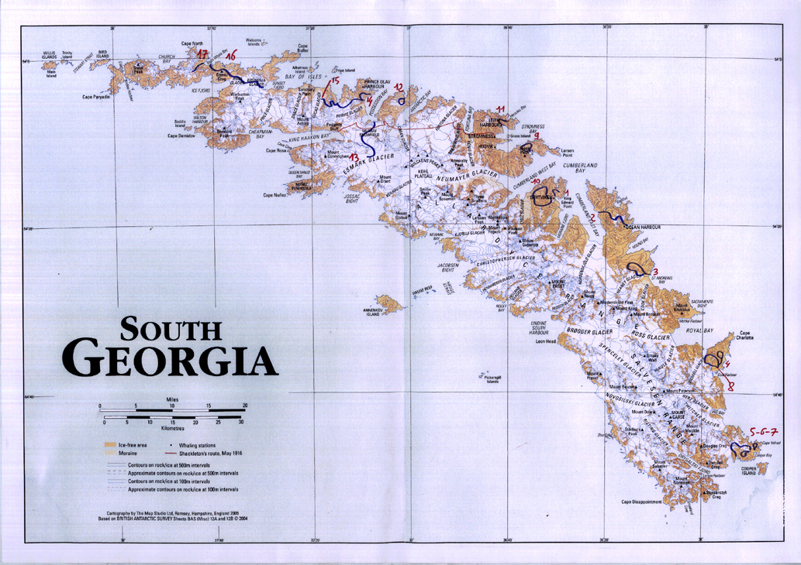
We had bivouac gear but we didn't use it, we have prefered to make one day ascent because of the meteo. So we have never slept on the island.
Please find enclosed to this message a scanned map showing all our inland itineraries (blue). Each track is detailed below (please report to the figure written on the map):
1. 8th of October : we arrived to King Edouard Point in the night. We spent 4 days and a half at sea (departure : Port Stanley – Falkland Islands) First mountaineering ski trip to Mt Duse – 507m, starting from Grytviken harbor.
2. 10th of October2 : In the morning, we sailed across Cumberland East Bay and joined Sandebugten. Ski trip : we walked across Barff Peninsula through Szilasko Icecap and arrived to Ocean Harbour
3. 11th of october : sailing to St Andrews Bay ,and landing. Pic 83 below.

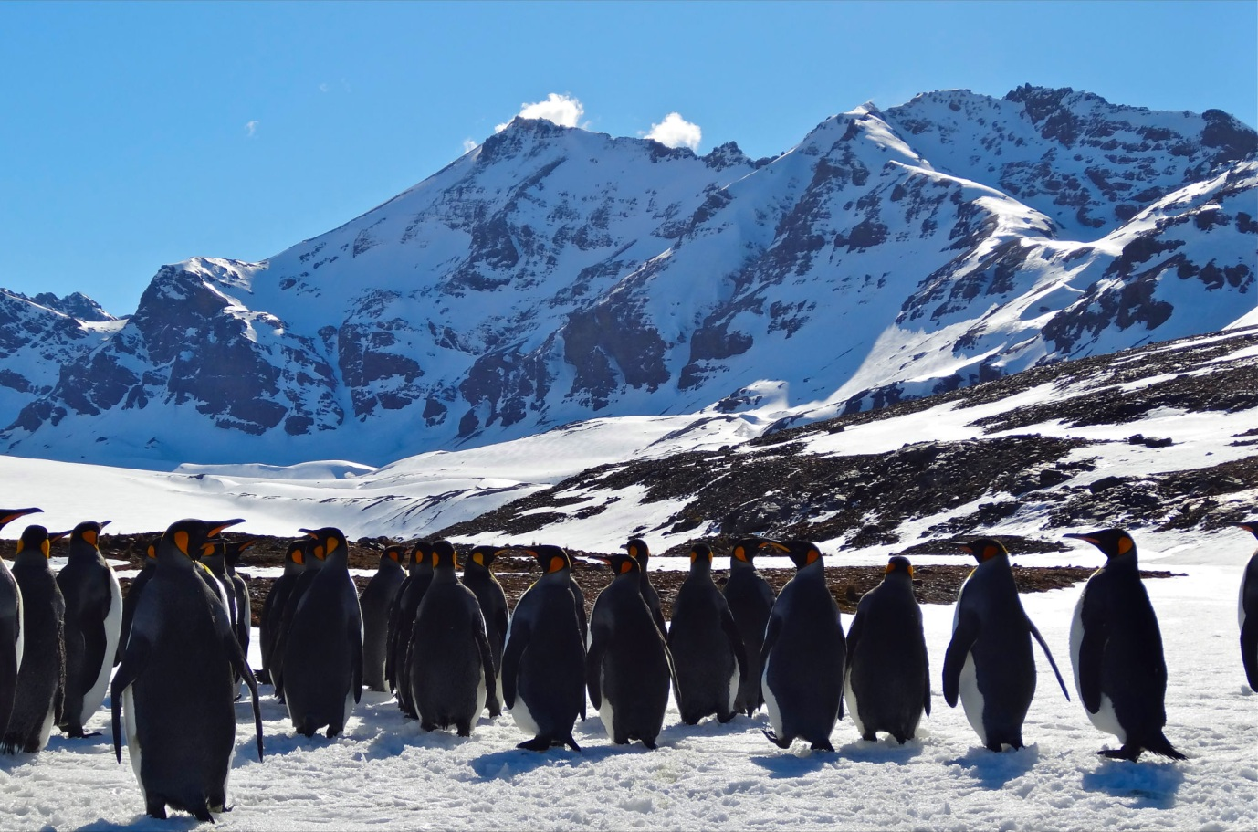

Ski trip : we went up Mt Fusiller through South East shoulder and North Face. We skied down through a corridor on the north face – 43 degrees inclinaison slope. We named it : the Ayla corridor - picture No 86 below).

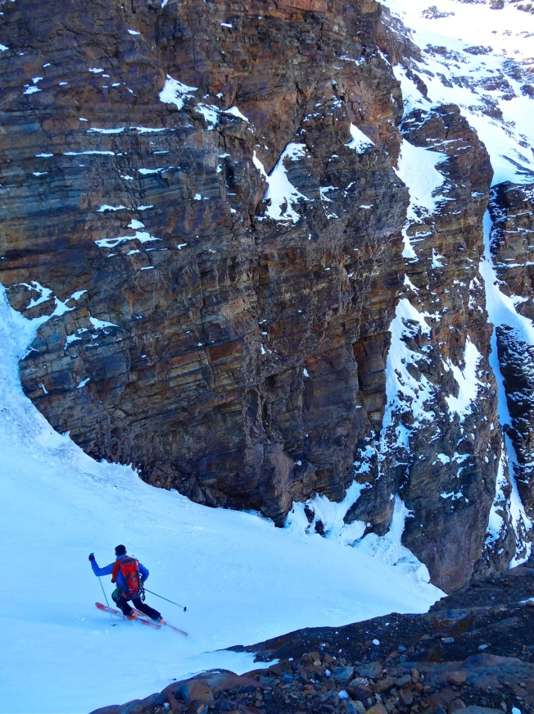

4. 12th of october : ,Sailing navigation to Gold Harbour ski trip: exploration above Wedell Glacier. Navigation and anchoring to Damien Bay
5. 13th Octobre : ski trip : We went up a little summit up Lewald Glaicer. Then we went across Quensel Glacier and we skied to Cooper Bay
6. 14th of Octobre : ski trip : we started from Cooper Bay. We went up a little summit on the South side of Quensel Glacier – bad weather after that
7. 15th of October ski trip : we started from Cooper Bay. We went up a little summit (we entitled it the Enora Peak 54°47-279 S 35°50 -923 W– picture N° 529 below),
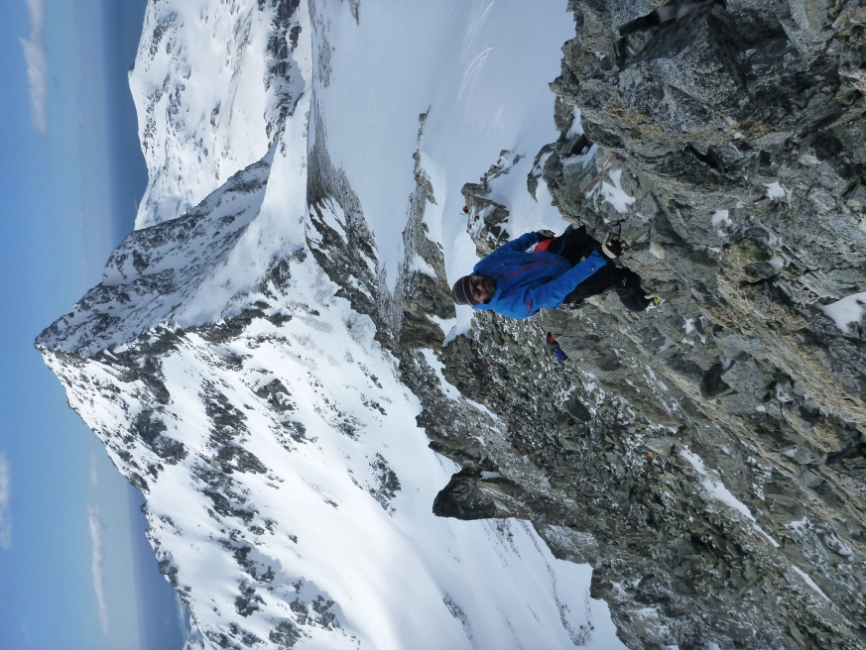

which is located on the South side of Fergusson Peak. We skied down through the North East slope (Lena Couloir photo N° 242 brlow).

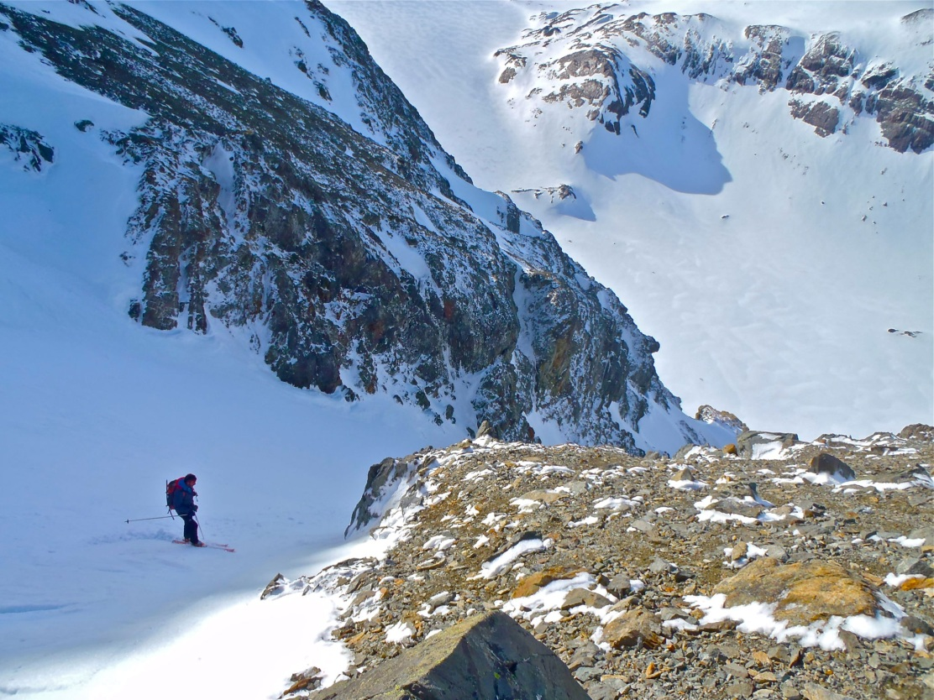

16th of october we observed animals in cooper bay
8. 17th of octobre : Sailing navigation to Gold Harbour ski trip : we went up a col up Wedell Glacier Afternoon : Sailing nnavigation to Jason Harbour
9. 18th of octobre ski trip : we skied accross Harrisson Point at the feet of the Jason Peak. We went down through the East Corridor of the Jason Peak

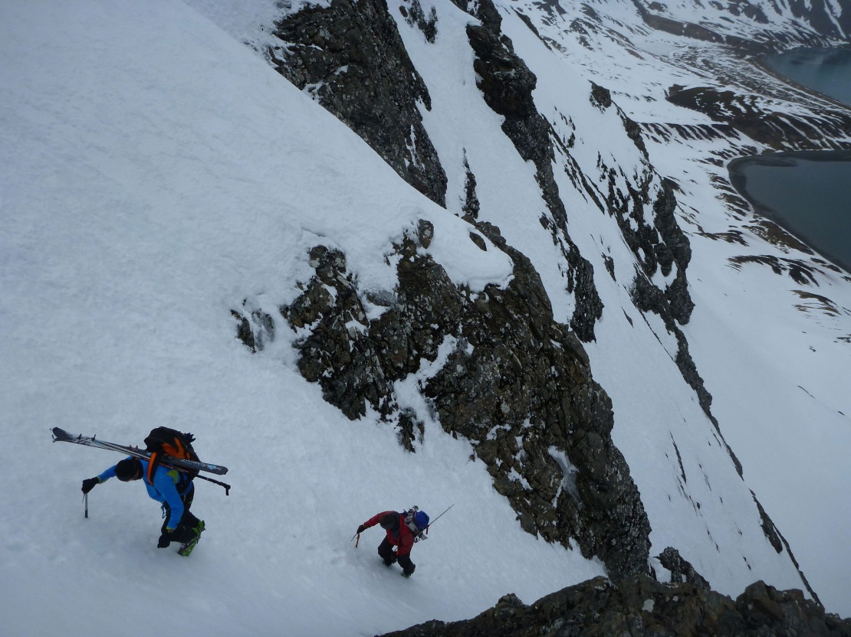
(entitled Celeste Corridor – photo N° 554 above)
10. 19th of octobre : sailing navigation to King Edouard Point and Grytviken ski trip : Getting around Hodgas through Echo Pass tour. We went up th little summit on the south side of Hodgas. « Torchitude Point » coordonées 54°16 - 751 S 36 °32 250 W - photo N° 133 below )

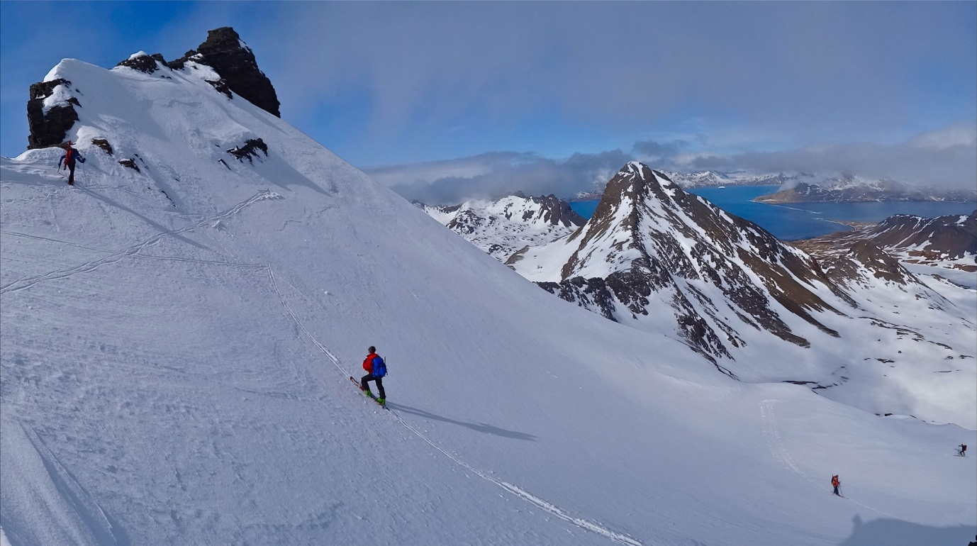
11. 20th of octobre : sailing navigation to Leith Harbour and landing ski trip : we went up to a path but we could not reach it ( coordonates 54°07 -925S 36°40 -400 W . We went through another path ( 54°07 751 S 36°41 312 W . Getting down to Hercule Bay 2st of octobre : resting and observing animals.
12. 22nd of octobre : sailing navigation to Blue Whale harbour ski trip : we went up to Blue Whale Mountain. The snow conditions wer dangerous and we decided to go back, despite of not having reaching the summit.
13. 23rd of octobre : Possession Bay ski trip : we started from Possession Bay and went up on the links side. We went across Murray Snowfield and Brigg Glacier heading toward Mt Worsley. We did not reach the summit and i stop the team 70 meters under the top because dangerous snow conditions and went back to Possession Bay
14. 24th of octobre : Sailing navigation to Prince Olav Harbour ski trip : we went up to a little summit (662 meters high) entitled Elephant Peak
15. 25th of octobre : ski trip : we started form Prince Olav Bay. We went across Austin Glacier and Morris Glacier. We arrived to Sea Leopard Fjord where S/V Podorange met us. Afternoon : landing and visiting Prion Island.
16. 26th of octobre : sailing navigation to Sunset Fjord ski trip : we went across Brunonia Glacier and Ryan Glacier and we went to Right Whale Bay
17. 27th of octobre : we attempted to get up the summit next to Ernesto Path but we had to renounce because of dangerous snow conditions.
Afternoon : observing animals on Right Whale Bay. Then we left South Georgia and sailed to Falklands. We arrived there on November, the 2nd.
III. Safety plan evaluation
We did not meet any problem during our trip - regarding sailing as well as ski moutaineering. We think our safety plan was adapted to our activities. Having a support boat is a necessity to undertake such an expedition in South Georgia.
IV. Summary
We really enjoyed our trip to South Georgia. We were amazed by the beauty and wildness of landscapes and animal diversity.
We hope that South Georgia remain so wild and we encourage next visitors to go on respecting such a natural jewel.
We thank Government of South Georgia for having permitted our group to undertake such an expedition.

