**REPORT ON THE SHACKLETON TRAVERSE FROM PELAGIC AUSTRALIS – OCTOBER 2013**

After having completed four Shackleton Traverses from King Haakon Bay tro Stromness since 2006, looking back after the current failure I have to admit in being perversely satisfied at the result. The island certainly lived up to its reputation for unpredictable weather conditions with big dumps of precipitation and savage winds. It is not a given that any party will successfully complete the route, and of course if it was, we probably wouldn’t have attempted it in the first place. Such is the attraction of uncertainty which must be a feature of a true adventure.

Our eclectic traverse team of sailing friends Cam Lewis, Gretchen Scott, Larry Rosenfeld and Amy Drinker (USA) were joined by sailor/alpinist Giorgio Bertone from Genoa ; the party being led by myself and mountaineers Julian Attwood and Ed Douglas (UK).

A cracking downwind sail from Stanley, twin headsails ‘poled out’ all the way brought us directly into King Haakon Bay on October 18th. We anchored close aboard the eastern side of the Vincent Islands, an illusionary shelter in anything except relatively settled conditions which didn’t last long. The strong westerly flow we had so well rode in on from Stanley persisted for the next four days making the traverse start untenable at best. Rain, sleet, then snow all driven horizontally off and on understandably dampened enthusiasms. Starting out wet with no visibility is not an option and in spite of having GPS positions from previous traverses, a necessity is to have reasonable conditions and visibility at least to get safely established on the expanse of the Murray Glacier - hopefully in minus tempratures to avoid a soaking.

This condition highights the dilemma cruise ships have when attenmpting the traverse with their strict schedules. The pressure from clients to start in similar conditions being their only opportunity is a tricky situation not to be underestimated and it takes a strong willed guide, at the risk of disappointing his clients (and the company advertising this add on option) to say ‘no go.’ We remember what can happen when two years ago a group from a ship set out in what must have been similar conditions. Of course ship parites have a second chance if they fail to deploy from King Haakon in that they can try again from Possession when the ship motors around, but this must put pressure on the on board Expedition Leader by the clients who are cruise only, and in the vast majority.

Eventually on October 20th we mustered the will power in spite of the weather to cache the skis, pulks, camping gear and provisions and fuel for at least five nights out at the snow line near the ice of the Shackleton Gap. We appreciated the load carrying from the Pelagic Australis crew of skipper Magnus Day, Laura Hampton (both UK) and Thomas Geipel (Germany), joined by Mike Spencer from America. The following day was scrubbed with again strong winds, rain and then snow.

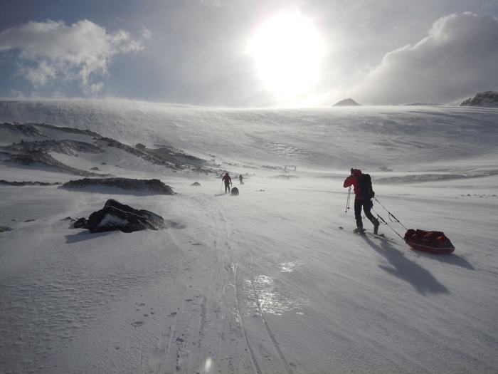

MAKING FOR THE SHACKLETON GAP IN COLD AND WINDY CONDITIONS

Early on October 22nd, we made a break for it in windy but clear conditions during a frosty and brief southerly shift that brought new snow down to the waterline. All went well on day 1 ascending to the level of the Murray, needing hartscheisen (ski crampons) on icy, wind scoured lower slopes. We continued on across the Murray and half way to the Trident thick weather arrived with a westerly shift bringing more snow. In spite of having a GPS position for the Trident Camp, the vague appearance of a rock buttress was a false target and we wound up too far right on the edge of the wrong windscoop, so moved around left and made camp just below the middle col of the ridge (it is recognized that Shackleton, Worsley and Crean took the left hand, higher col for their passage). Lesson learned here is to get out the specs and read your GPS no matter what!

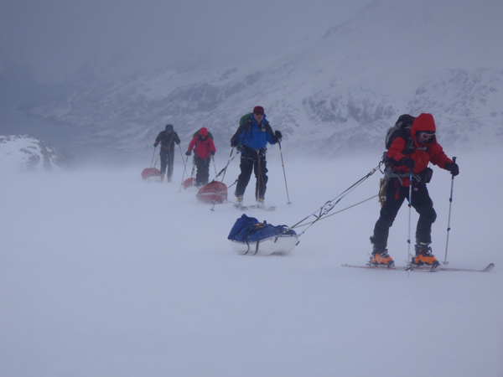

SKINNING UP TO THE LEVEL OF THE MURRAY GLACIER

So far so good, but that night it continued blow strong from the west bringing at least 300mm of snow and it was clear this would make the downside of the Trident a wind slab avalanche risk. To safely descend the Trident with a mixed group, requires a long process of lowering off the pulks, 180 meters at a time (3 x 60m ropes tied together anchored by a snow stake), digging out ledges, bringing everyone down the rope on a prussic in view of known crevasses on the slope, and then repeating this game three times to reach the flat on the Crean Glacier. Given the weather conditions, poor or nil visibility and the time this would take on a potential avalanche slope was deemed unacceptable, so we made the decision to descend back onto the mid Murray and call in Pelagic Australis for an eventual pick up in Possession Bay as the weather forecast that night was more of the same for the next 48 hours at least.

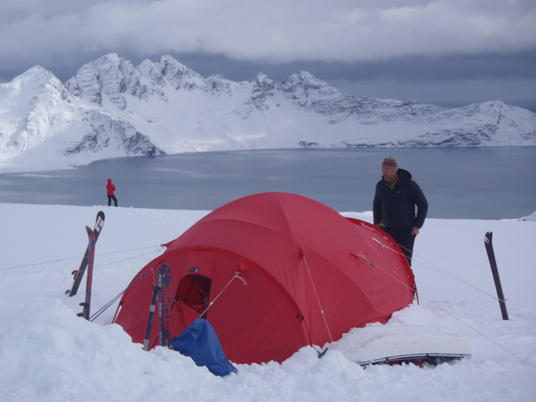

CAMP ABOVE ASSISTANCE BAY EAST

During a camp above the east arm of Assistance Bay we experienced a hard night of very strong south westerly winds accelerating over us katabatically approaching tent busting conditions and most of us had little sleep. Easing slightly by morning, the weather kept us tent bound the following day and during the evening the wind slacked off for a relatively quiet night on the 24th.

By this time Pelagic Australis had motored around the northwest tip of the island in thick weather and was at anchor in Cook Bay near the whaling station Prince Olaf. After a visual recce of a possible descent route by the sailing crew, albeit in less than clear visibility, we left the campsite at 1000, having seen another party from the French yacht Les Sourire climbing up to an extension of the Trident well north of the classic Shackleton descent into the Crean. They had started from the western arm of Assistance Bay and this was their second attempt at the traverse having had the same windy weather that we had sailed in on. Maybe they knew something we didn’t? They disappeared in the mist as we descended a snow ramp down to the eastern arm of Assistance Bay to the waiting dingy; which for future reference is not a desired exit (although a quick one from the Trident) as it was threatened in the final part from ice cliffs above, only revealed in the mist well down the slope. Better to have gone farther west around Glacier Point and down to the western arm of Assistance Bay from the classic Shackleton Gap. This is an important point as the eastern arm appears doable from the map, but one enticing ramp on the right leads to an impasslbe ice cliff and our ramp on the left was indeed threatened from seracs.

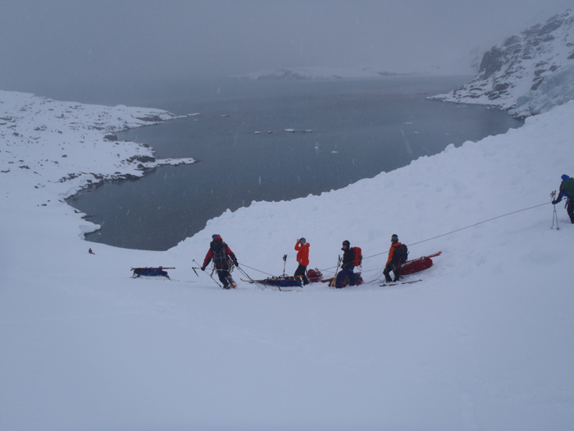

DOWN TO ASSISTANCE BAY EAST

Happily back on board, we spent a windy night in Cook Bay, and then scuttled off to Fortuna to attempt a day outing to ski up the Fortuna from Anchorage Bay, go up and over the Breakwind Gap and on around to Stromness. After a tour of the Kings at Fortuna on October 26th with Le Sourire now also in the anchorage, we watched their skiers descend into Anchorage Bay, having spent a windy few nights on the Crean. Next day we skied back up part of their route to gain the Fortuna with fine views of Mt Stanley and the Great Nunatak that was the steering beacon for Shackleton, Worsely and Crean when they crossed from the Trident. We skied up to and cramponed over the Breakwind Gap in zero vis, which later cleared with less than safe skiable snow conditions further down the gully. Snow patches on the grassy lower slopes happily linked together which brought us right down on our skis to the beach at Whistle Cove.

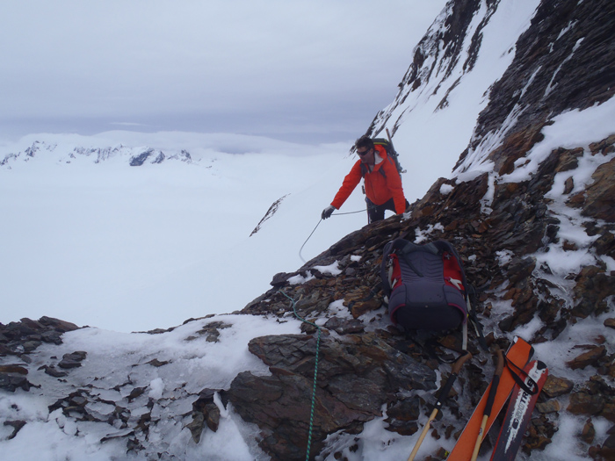

UP AND OVER THE BREAKWIND RIDGE

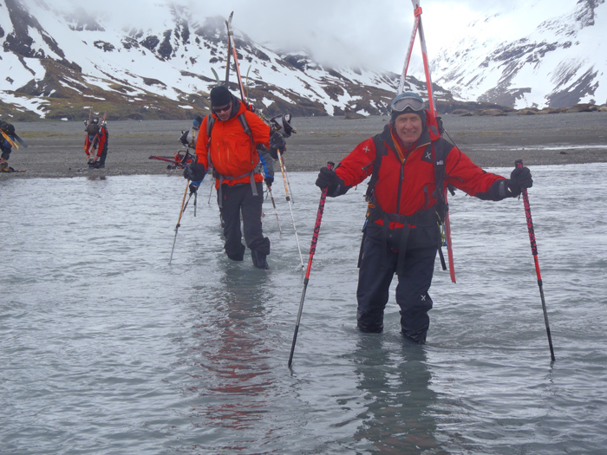

CROSSING THE KONIG RIVER

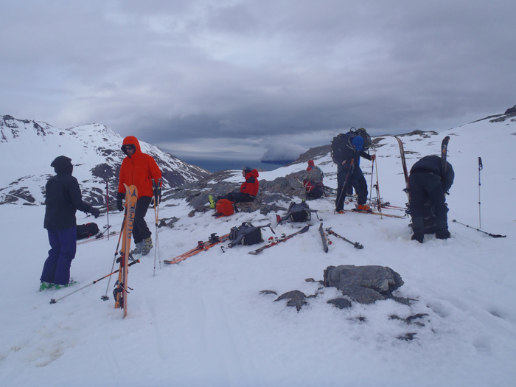

THE COL ABOVE CREAN LAKE LOOKING DOWN INTO STROMNESS BAY

I missed not having the time to camp on the shingle beach at Fortuna Bay, able to revel in a bit of greenery, as we normally do after days up high. Instead, the boat came around in quick time, took our climbing gear off and we went light with rubber boots, carrying skis and ski boots across the outwash plain of the Konig Glacier, skinned up to the col above Crean Lak and skied down to the braided river than empties into Stromness Bay. Shackleton Route – 3/4’s done!

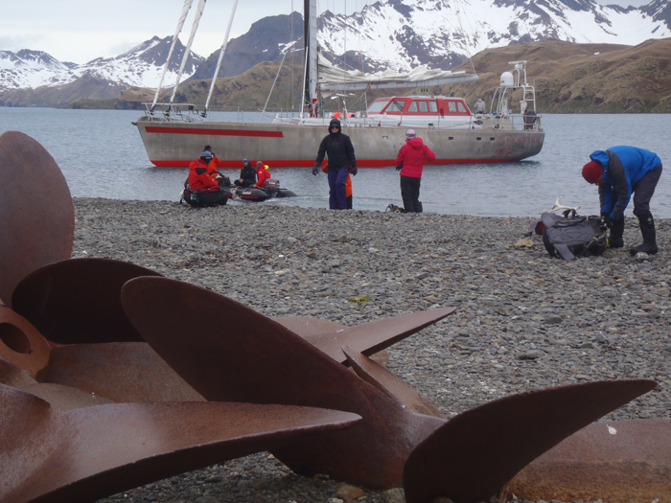

BASE CAMP PELAGIC AUSTRALIS FOR THE PICK UP

Summary: Supported by Pelagic Australis, an attempt on the Shackleton Traverse from King Haakon Bay, foiled by strong winds, heavy snow fall and avalanche risk on the Trident Ridge. A descent into Assistance Bay (Possession Bay) and pick up then sailing on to Fortuna Bay to complete the traverse from the Fortuna Glacier, Breakwind Gap and on to Stromness. No incidents to report.



A Conclusion from a ‘five timer:’ There appears to be two styles that have evolved over the years in doing the traverse . Go light and fast and get it done (as had Shackleton, Worsely and Crean), or go heavier and more cumbersome; taking shorter days, having more flexibility and some time to ski mountaineer en route and actually enjoy the scenery and total experience. There are arguments to be made with regards safety as the light and fast approach does have merit in any mountain environment; but if ‘caught out’ you have little or no reserve in food or fuel. This might be critical with an inexperienced tourist group. Going heavier with more flexibility (read staying power), is more work, but taken at a slower pace is not only more enjoyable, but does seem a safer way to go, less prone to accidents that can happen at pace.

Skip Novak