Post expedition report, SG2010
”Circumnavigation on South Georgia by seakayaks 2010”

Expedition Leader: Simen Havig-Gjelseth, born 1971
Expedition members: Tormod Austring, born 1981
Sigrid Henjum, born 1983
Dag Marius Ammerud, born 1971

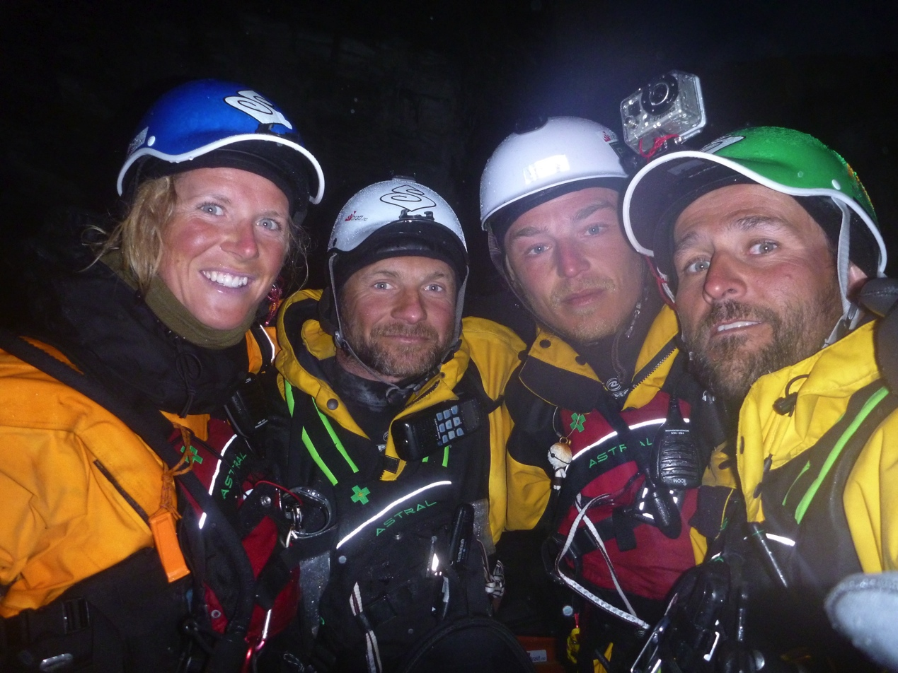
from left to right: Sigrid, Dag Marius, Tormod, Simen
Time:
We started out from Stanley November 1st onboard the sailing yacht PELAGIC, the sail down to Grytviken took us 6 days. We commenced padling november 11th and finished December 1st. Sailing back to Stanley took an additional 9 days.

Logistics:
The kayaks were sent to Grytviken from Oslo by the cruise vessel MV FRAM. The transport of the kayaks took almost 6 months due to their cruising activity in the northern hemisphere.
Our expedition food were sent by airfreight to port Stanley. Our fuel were purchased by the PELAGIC crew in Ushuaia.
The rest of our equipment we carried with us when we came down to the Falkland Islands.

The Kayakking:
- The route: we paddled counter clockwise with start and finish in Grytviken. Counter clockwise is by far the best direction due to the sea and wind conditions on the south coast.
- Our camps: camp 1: Hercules Bay, camp 2: Elephant Lagoon, camp 3: Sea Leopard fjord, camp04: Sheatbill bay, camp05: Cape North, camp06 Johan Harbour, camp07: Coal Harbour, camp08: Elephant Cove, camp09: Nilsehullet, camp10: Sandefjord, camp11: Ducloz Head, camp12: Diaz Cove, camp13: Ranvik, camp14: Smaaland Cove, camp15: Royal Bay, Camp 16: Louisa Bay.

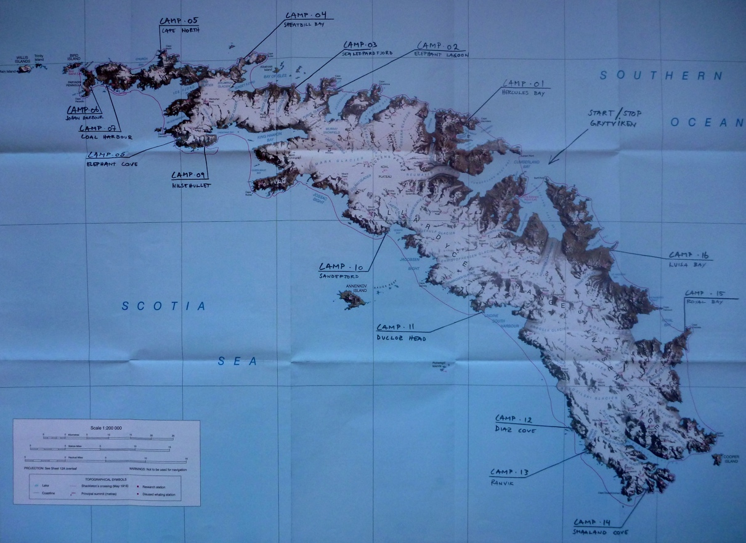

Challenges:
On the leg from Grytviken to Bird Sound, the Fur seals and the Katabatic winds were the biggest challenges. However, we learned to live with the fur seals, and it seemed that they learned to accept us. Every lunch and evening we had to fight our way onto the beach. We learned that usually it is sufficient to tap the paddle on the pebbles as the seals are sensitive to ”hard” sounds. We needed to clear 25 square metres of flat beach to pin or tent and placed the kayaks around as a defensive wall.
The katabatic winds were strong and we paddled very close to shore on the entire north east shore, in order not to be blown out to sea if when we got the gusts out from the fjords.

Bird Sound was the first taste of the south coast and we were impressed with the size of the waves in the sound, large and totally chaotic. We made it around the corner to Johan Harbour and was extremely releaved to have made it there without any capsizes that day.

Continuing on the south coast we experiences strong winds up to 60 knots in Elephant Cove, ice in the sea infront of the large glaciers, we paddled in seas up to 7 meters high and had two capsizes outside Ranvik where we had to wait for the weather to come down.

An other challenge on the south coast was an Elephant seal, male, destroying one kayak by ”climbing” over it during the night. This was in Ducloz Head, we managed to fix it and was on the water some 6-8 hours later after having used all our supplies of fiberglass and polyester for the repair.

The rounding of Cape Disapointment was a rough ride. We were very happy that afternoon when we got into Smaaland Cove and pitched the tent for the night. At this stage we knew that we were going to make it around the island.

The remaining of the east coast was quite smooth, with the exception of crossing Drygalski fjord where the wind was shooting out, however we got it mainly in the back and ”flew” across. Also after Louisa bay we were stopped by the weather and had to wait an extra day.

At December 1st we were back in Grytviken and the people from KEP invited us in on a beer, a shower and a sauna. It was great!
We did the circumnavigation in 20 days without any supplies or assistance from our support vessel.

The expedition was very well planned, and we had been training for two years. That, combined with fairly good weather was the keys to our success.

If someone came up with the funds, and I could get time off work I’d do it again, no worries. South Georgia is truly an amazing place!

Please read more on our blog:
www.southgeorgia2010.blogspot.com

Best regards,
Simen Havig-Gjelseth,
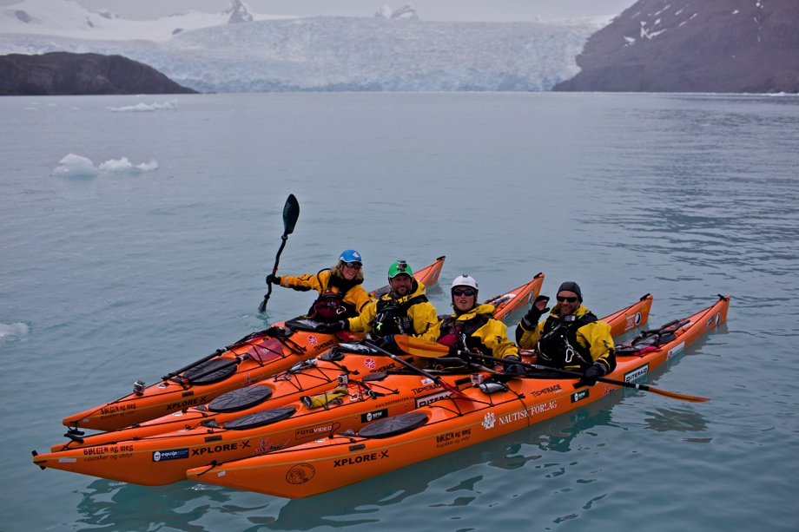
expedition leader, SG2010

