Intrepid-DX Group Post Expedition Report-January/February Expedition to Southern Thule and South Sandwich.
By Paul S. Ewing
Expedition Team members:
Leader-Paul Ewing-USA (planning & logistics)
Co-Leader-David Collingham-USA (radio operations)
Members:
Jun Tanaka-Japan
David Jorgensen-USA
Jay Slough-USA
Dr. Mike McGirr MD-USA (Team Physician)
Axel Schernikau-Germany
Ned Stearns-USA
Roger Hoffman-USA
David Asaff III-USA
David Ritchie-USA
Dmitri Zhikharev-Russia
Dr. Arliss Thompson MD-USA (Team Physician)
Support Vessel: RV Braveheart:
Nigel Jolly-Owner
Neil Broughton-Captain
Jason Kelman-Mate
William Roundhill-Mate
Charlie Beadford-Mate
Nick East-Chief Engineer.
Summary:
Our plan was to voyage from Stanley to Southern Thule Island by way of KEP to camp at Hewson Point and conduct an eight day amateur radio exhibition. We were then to voyage three days to Husvik Bay, South Georgia and conduct a similar eight day amateur radio exhibition. Initially, weather was good on both islands however very strong storms appeared and caused us to curtail our operations shortly before we planned. We consider both expeditions very successful and we are very satisfied with our results.
Details:
Our plan was for all of the team members to begin travelling to Stanley, the Falkland Islands on January 7th, 2016. On January 9th, we boarded the Braveheart, met the crew and got settled in. All of our gear was stowed and secure.
At first, the seas were calm and we enjoyed the voyage. Within a few days, we were voyaging along the Drake Passage and the seas became quite rough and dramatic. It was interesting to be in the Braveheart wheelhouse as waves broke over the bow of the ship. We often saw large ice bergs as we continued our voyage south.
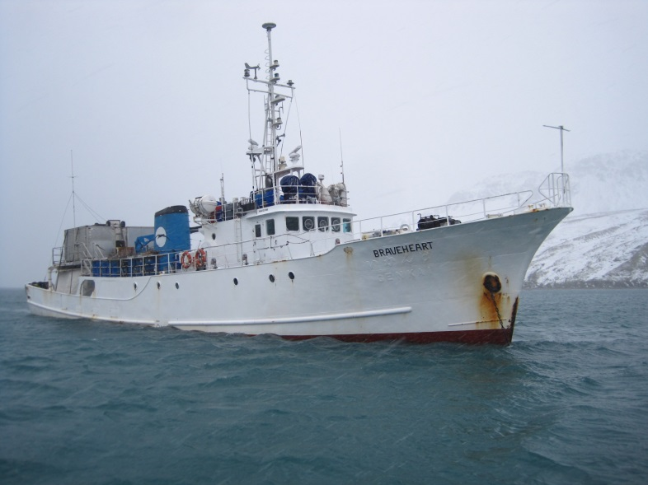
The RV Braveheart at anchor King Edward Point.
On January 14th, we arrived at King Edward Point, South Georgia where we had to check in with a customs officer and go through a ship inspection. We briefly visited the old whaling village of Grytviken and paused for a moment to pay respects at the gravesite of Sir Edmund Shackleton.
We then made the three day voyage to Southern Thule Island, the southernmost island in the South Sandwich chain of islands. We arrived at Southern Thule Island on January 16th. The Braveheart launched their RIB boat and the crew began to search the coast line for a safe landing place. The crew returned a short time later and reported that we would need to land in heavy surf. Nigel asked for volunteers to don “Immersion suits” and make a landing attempt. David, Jun and Ned were outfitted in the immersion suits and soon left to attempt a landing. Their goal was to find a suitable campsite far away from the wreckage of the old Argentine base.

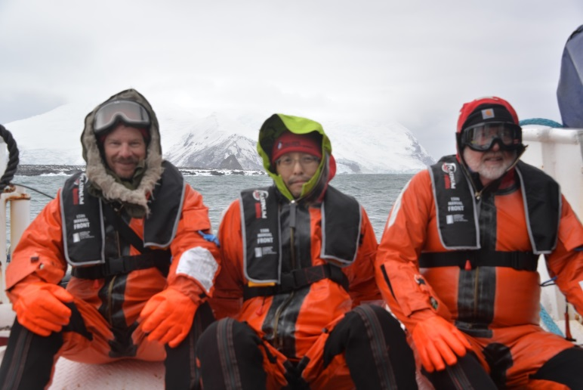
Three team members in immersion suits about to go onto Southern Thule.
I watched through binoculars as the team tumbled through the waves and went ashore. Soon, they trekked across the flat area of Southern Thule Island where they found an acceptable landing site, a site that had been used before as a long thick blue plastic rope was secured all the way down to the water line. This would become our landing site. Unfortunately, the area was strewn with wreckage from the Argentine base which covers a very large area.
Soon, the Braveheart steamed around to the other side of the island and the small rigid inflatable boat (RIB) was launched. Ten of the team members were shuttled ashore while three team members remained on the Braveheart to help with the loading of our gear.
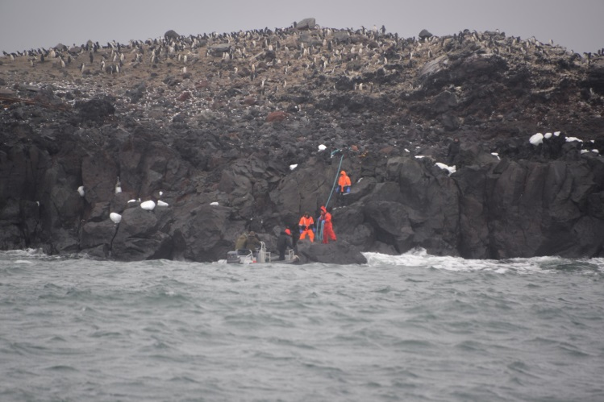
The blue rope line used to climb the rocks onto Southern Thule. Our campsite is above.
The landing on Southern Thule was not for the faint hearted. The RIB driver would place the bow of the boat against a large semi-flat rock right at the water line. Most of the time, this was done between waves. Two crew members stood on the rock and plucked the team member out of the Rib and handed him the heavy blue rope. The team member immediately had to begin climbing up the rocks or he risked being hit by the waves. Very little could be carried while on the rope line. After climbing about thirty feet, there was a landing point. From there, there was a 100 yard walk up a steep incline to a large flat area which would become our camp site.
Getting our gear and equipment out of the boat, onto the rocks and up the rope was a much more arduous task than moving people. A wave washed over one of our generators as it was being hoisted out of the RIB boat and onto the landing rock. It never did work quite right after that. We had packed our gear so that most of it could be carried by one man but it was still quite difficult getting everything ashore.
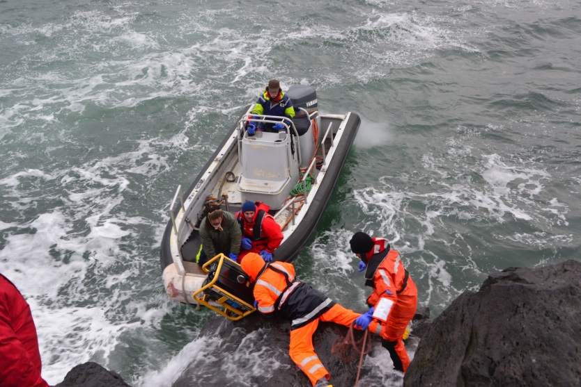
This is how equipment and personnel were brought ashore.
We quickly set up our tents and outfitted our campsite. A small shelter was created for our generators. . A row of antennas was set up on the edge of a cliff facing to the north. There was a large flat area behind our tents that would provide an area for our vertical antennas. The ground was frozen during our stay so anchoring antenna guy ropes was always a challenge.
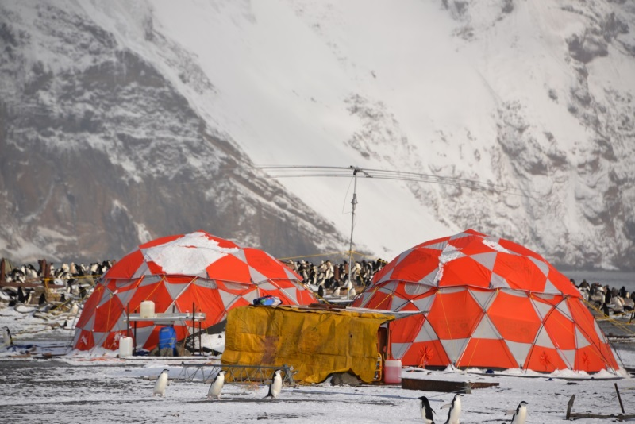
We were fortunate to have relatively good weather on both islands during our first five days. Winds were always strong and it was very cold, particularly at night.
At 59 degrees south, the sun never really sets and it does not get fully into darkness. This was good as we often had to go out day and night and tip up antennas that were blown down or re-secure the tent.
We typically saw four seasons within the span of 24 hours. When the sun came up, there was fresh snow on the ground. By mid-day, the sun was out and the ground was clear of snow. The winds came up in the afternoon and we often saw snow flurries before dark. This was repeated daily until January 24th when the first of two storms arrived. Our two primary tents were polar rated however we found it increasingly difficult to keep them clear of accumulating snow and keeping their tie ropes secure in the frozen ground.
The Braveheart crew came ashore each day, bringing the radio team hot meals and tending to the generators. Great care was taken not to spill any fuel.
During our explorations, we found the “Rescue Hut” It has received significant storm damage and is turned on its side with many Penguins living inside.
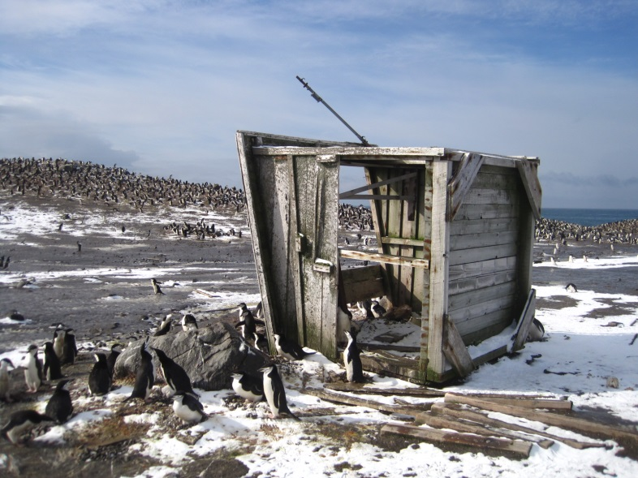
The Rescue Hut is now lying on its side. Wildlife is living within.
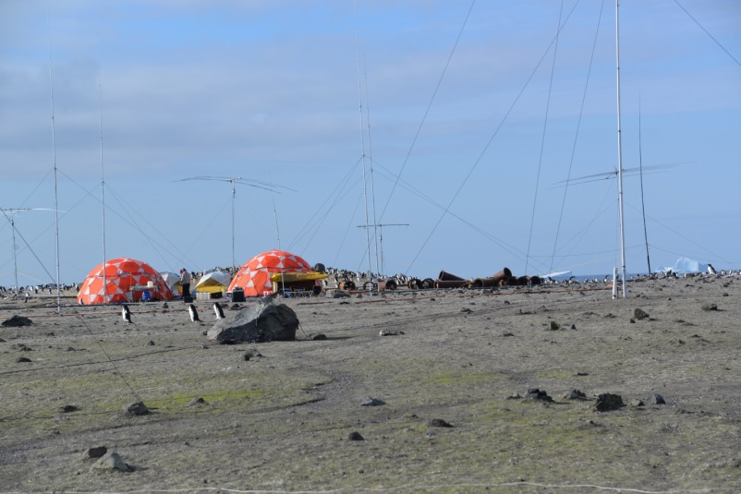
Our campsite with many antennas and guy ropes.
Later that night, winds increased to 70 knots as reported by the Braveheart. Our tents began to collapse under the pressure of the wind and the weight of the snow. We had a harrowing evening as we had to physically hold up our tents with our bodies. We regularly cleared the snow and re-secured the tie ropes but it seemed that we were losing the battle against “mother nature”. The Braveheart called us on the VHF radio and reported that they were moving out to sea as they were having difficulties in the bay near us.
The next morning, we had four feet of new snow on the ground. Many of the antennas were on the ground and we had to dig them out to put them back up. Two of our four tents had fully collapsed and were damaged beyond repair. Through all of this we managed to keep a few stations on all night. We were now running at full strength again when I received a call from Nigel on the VHF radio. Nigel declared an Emergency and ordered an immediate evacuation of the island. He asked us to get to the landing rope as fast as possible. The Braveheart was steaming into the strait between Thule and Cook Island and they saw that a large area of pack ice had been broken away in the storm that previous evening. Nigel feared that the pack ice was going to block the strait and that if that happened they would not be able to get to us for a number of days.
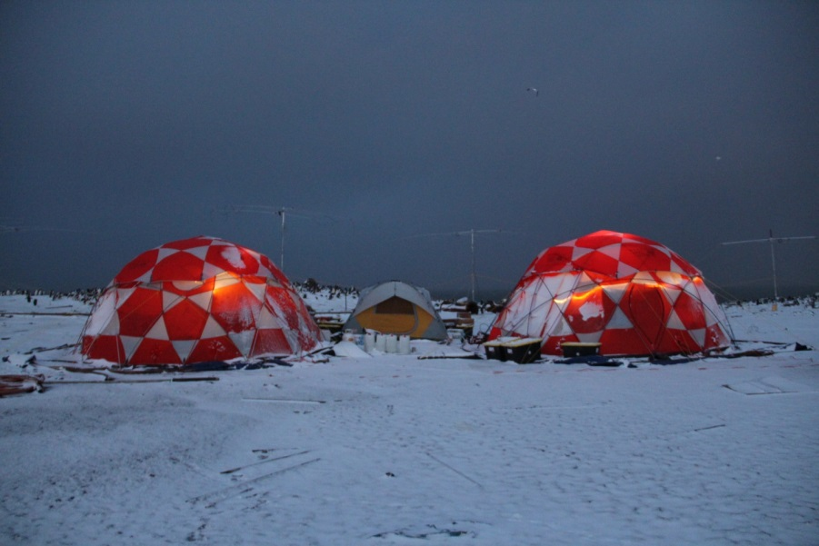
This is about as dark as it became at Southern Thule.
We quickly turned off the generators and abandoned all equipment in place. We made our way to the landing rope just as the Braveheart arrived into the bay. Soon, the rigid inflatable boat arrived and whisked us all aboard the Braveheart. Most of us were exhausted and welcomed the chance for a hot meal, a shower and a nap in a real bunk.
On January 26th at 4AM, we went back onto the island to recover our gear. We had no idea what condition any of it would be. The two main tents were still standing and our gear was safe and dry. Many of the antennas had fallen and were on the ground but at this point we decided to vacate Southern Thule Island after eight days of operating.
It took eight hours and exhaustive manpower but we packed everything and put it aboard the Braveheart. We searched the entire camp site for any litter or debris. We took photographs to document that we left the site just as it was when we arrived. We took stock of our gear and our people and everyone seemed willing to voyage to South Georgia as planned.
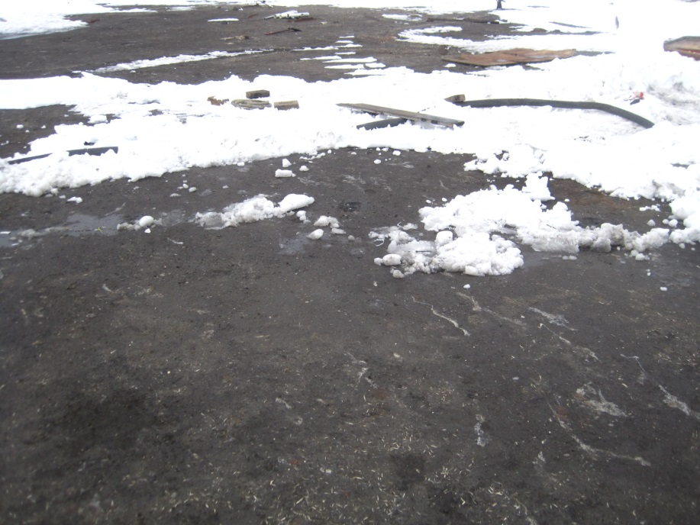
This is the site of our camp.
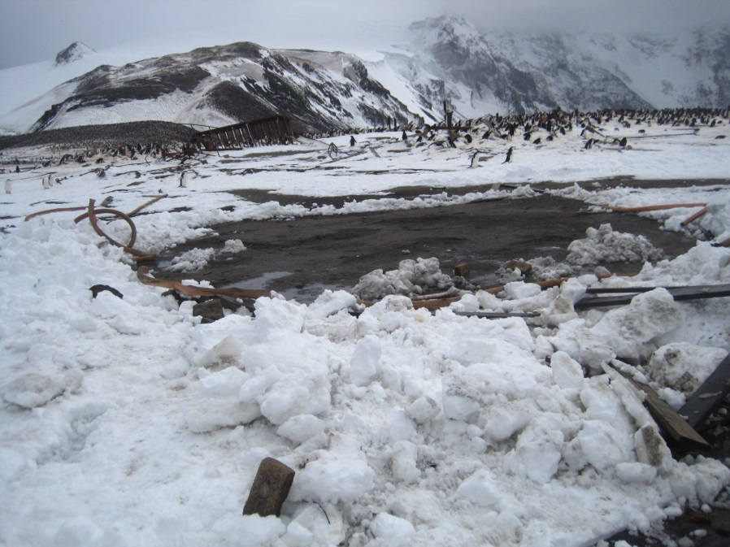
You can see the outline of our tents. All debris has been picked up.
On January 29th, we arrived at Husvik Bay, South Georgia. The weather was clear and we easily landed on the beach. We were immediately met by Sally Poncet and Ken. They suggested a camp area on the southern end of the beach. This appeared to be an ideal location. Sally and Ken cautioned us about strong winds in the afternoon.
Since the landing was not difficult and the Braveheart was able to anchor offshore, we decided to set up only one of our polar tents. The team would be able to return to the Braveheart in shifts for meals and sleep.
Just as we experienced at Southern Thule, our first five days of weather were quite good. We easily set up our radio antennas and operated quite well. On Feb 4th, we split into small teams and did some hiking and small boat sightseeing with the Braveheart crew. This was quite enjoyable.
On February 7th a strong storm arrived in the night. The radio team had great difficulty keeping the tent intact due to high winds and heavy snow fall. They were in VHF radio communications with the Braveheart and were instructed to stay in place and they would be extracted at sunrise. The Braveheart reported winds of 60 knots and gusts much higher.
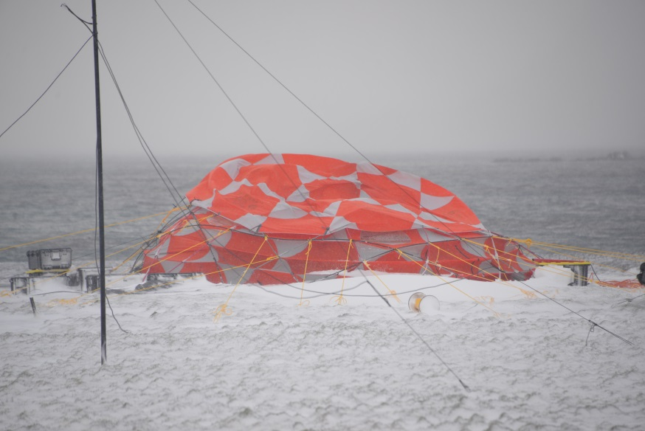
This is our tent, being hit with wind gusts in excess of 60 knots.
At sunrise, the Braveheart crew extracted the night team and placed a small group on the island to begin to gather our equipment. It was then that one of the sailboats in the bay crashed onto the rocks and the Braveheart attempted to assist them with their own small boat crew.
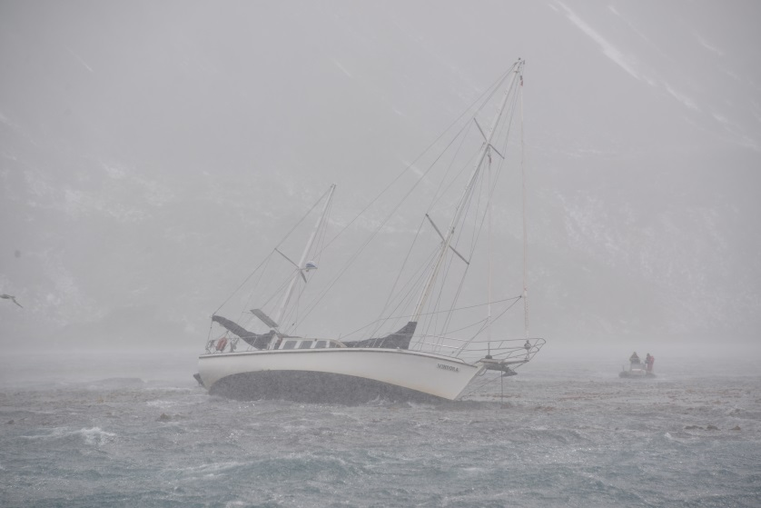
Members of the Braveheart crew try to help the sailboat Windora on the rocks at Husvik Bay.
The next day, the weather was good and we were all able to go ashore and pack up our tent. We carefully patrolled the camp area and picked up any trash or debris, making certain we left it just as we arrived.
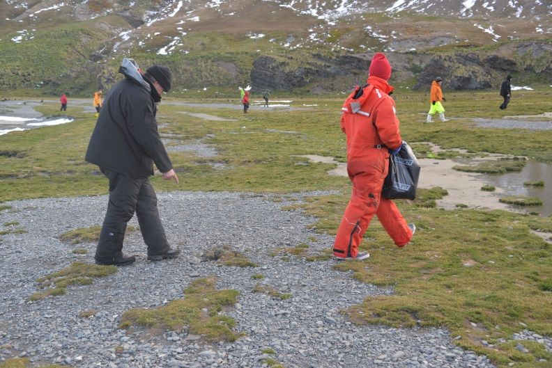
Team members search the camp area to remove any debris.
On February 8th, 2016, we started our five day return voyage to Stanley aboard the RV Braveheart.
In closing:
I can’t say enough what an ideal support vessel and crew we had with the RV Braveheart. They are exceptional seaman, very highly skilled and they always operate in a safe and prudent manner. We are glad that we were able to bring two Physicians on our Expedition regardless of the fact that we had no medical issues other than seasickness.
We have some doubt that our Polar tents were up to the challenge. Perhaps we should have been more attentive to remove snow loads and to have replaced problem tent poles earlier on.
Thank you for the opportunity to allow us to conduct this Expedition.
Sincerely,
Paul S. Ewing

