SOUTH SANDWICH ISLANDS EXPEDITION REPORT
JANUARY 2020
THE NARRATIVE AND LOGISTIC CONSIDERATIONS

The project to visit the remote and little known South Sandwich Islands was three years in the planning. This included a comprehensive scientific permit application procedure conducted by the Government of South Georgia and the South Sandwich Islands.

The expedition vessel Pelagic Australis managed by Pelagic Expeditions was engaged to offer transport and logistic support to the team of eight scientists and the two man film crew. Three professional sailing crew on the vessel plus an Expedition Leader rounded out the compliment to 14 all up.

It took two full days of preparations and briefings (that actually started in the Holiday Inn Airport Hotel in Santiago!) while on the Public Jetty in Port Stanley before we could sail. Stowage of a mountain of scientific and safety equipment, rigorous biosecurity checks on all our clothing and equipment and last minute firmware updates for the quiver of RPAS (UAV/drones) kept us all busy. There had to be a household briefing detailing the galley, operation of the toilets (most important!) and where tools, provisions, and misc. gear was kept on board. A tour of the deck to demonstrate the use of winches, furlers and basic line handling for the landlubbers of the team was also completed. A safety briefing led by the captain and mate instructed the team in life jacket and life harness use, pyrotechnics, EPIRB deployment, use of immersion suits, man-over-board and abandonment procedures where everyone was allocated a task in the event of. We tried on our new dry suits, PFD’s, hoodies and booties for the expected ‘wet landings.’ We were truly ready to go so we could hit the first beach running. There was a lot on the scientific agenda in the five week schedule that included sailing to and from the islands, plus stops on South Georgia itself for more scientific objectives if time allowed.

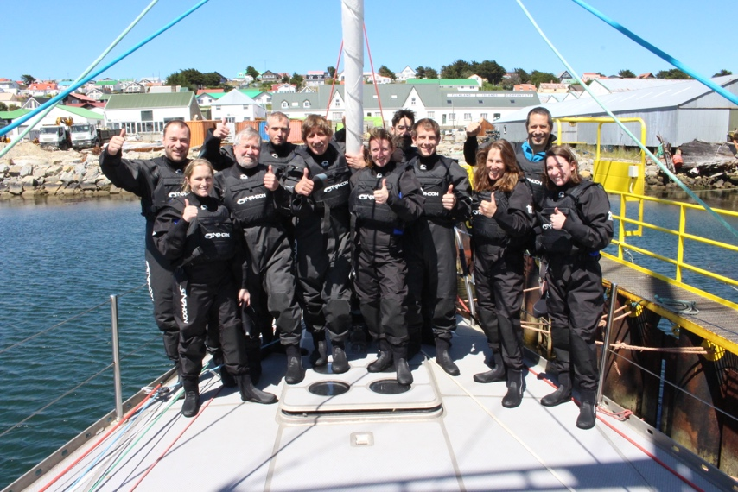
Biosecurity

Of utmost importance were the many issues of biosecurity. These were dealt with rigorously upfront as part of the permit application. It was decided to go straight to the South Sandwich, rather than make a customary stop in King Edward Point, specifically to lessen the risk of carrying any of the many invasive plant species found around KEP down to the islands.

Before we left Stanley we inspected everyone’s clothing, footwear and equipment down to vacuuming out pockets of jackets and pants, painstakingly picking seeds out of Velcroe with needles and disinfecting boots, ski poles, tripods and anything else that can come in contact with the ground.

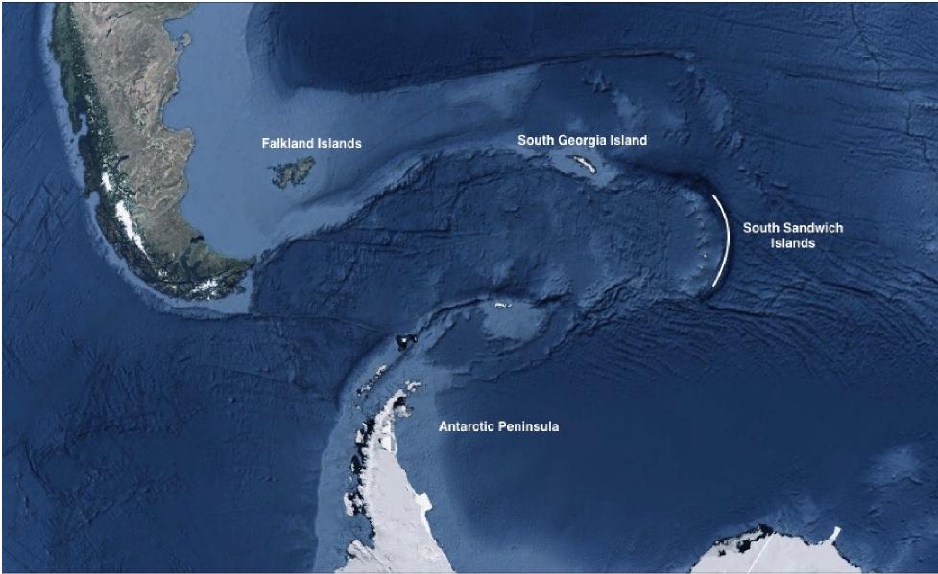

DEPARTURE

On December 31st we had a visit from Sammy, the four legged rodent hunter, and her handler Naomi Baxter. Sammy jumped off our deck still hungry so we could depart Stanley Harbour with the all clear for visiting these pristine islands. Hopes ran high, it was a beautiful day with Peale’s dolphins alongside as we slid past Cape Pembroke under a conservative single reefed mainsail and working jib with the wind on the starboard quarter. Captain Chris laid a course for Saunders Island in the middle of the South Sandwich chain. Saunders was a prime objective in the island group and the easiest one to get ashore, according to Co-Expedition Leader and science coordinator Dr .Tom Hart who had been there three times before. Before we cleared the cape Ted Cheeseman, co-founder of happywhale.org deployed his acoustic gear on 400m of Spectra cord. He would be recording whale ‘noise’ for the entire trip while underway in hopes of identifying the species through their audio signatures unraveled by an algorithm.

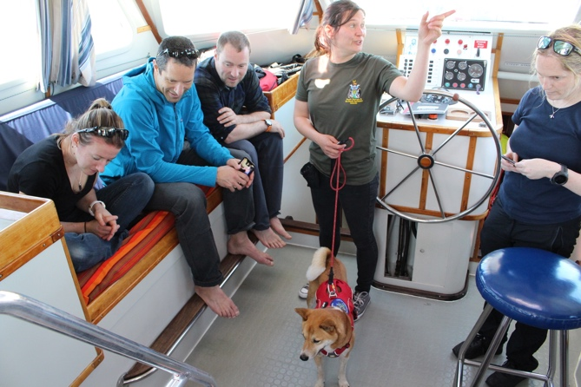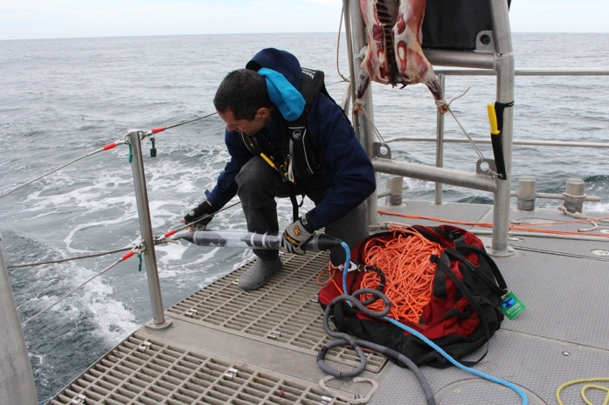

Although you always have to be optimistic, the reputation of this outlier chain of semi active volcanic islands, 300 miles southeast of South Georgia, was well known. Notorious winds and storms in the Southern Ocean could make the 1000 nautical mile journey to the islands potentially dangerous. Returning back upwind could be fraught with difficulty and delays if faced with strong northwesterly winds. There was risk of ice throughout the entire voyage - ice bergs, bergy bits, growlers - especially at the southernmost islands as they are beset by sea ice in the winter. Once at the islands, there would be difficult or impossible landings due to the enormous swells of the Southern Ocean in view of the small size of the islands. Shore parties would have to be light and fast, and be ready to get wet. Additionally, there would be poor anchorage sites and little protection from significant storms. Team members knew that based on prior expeditions, the islands had a reputation of offering up only 10% out of what you set out to achieve. This was no place for a holiday!

The sail to Saunders Island was a pleasant run down wind, and otherwise uneventful, being calm enough for the science teams to collaborate and plan on objectives. Team Penguin (Dr. Tom Hart, Oxford and Dr. Gemma Clucas, Cornell www.penguinwatch.org ) had plans to census the colonies of chinstrap and Adelie penguins with RPAS (drones). Dr. Jo Feldman, an A&E doctor from California would also assist this team in taking fecal and blood samples for DNA analysis in addition to satellite tagging 20 chinstraps to follow their foraging range.

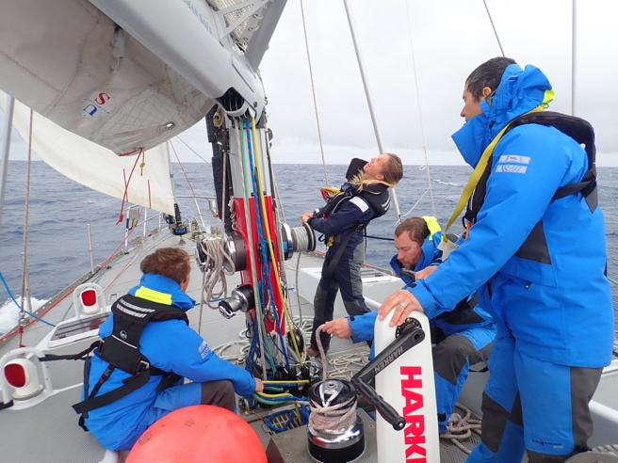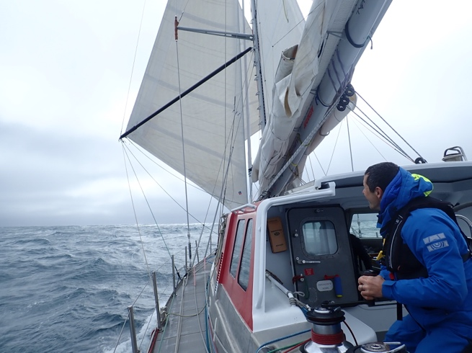

Team Ice (Professor Paul Mayewski and Mario Potocki, University of Maine Climate Change Institute) would be drilling for ice cores and taking snow and water samples. Team Volcano (Dr. Emma Liu, University College London and Dr. Kieran Wood, Bristol University) had designs on inspecting a possible lava lake in the crater of Mt Michael on and would also be collecting rock samples and using RPAS to take gas samples from the volcanic plume. Ruth Peacey and Hamsa Yassin were to film all of the above so had their work cut out for themselves.

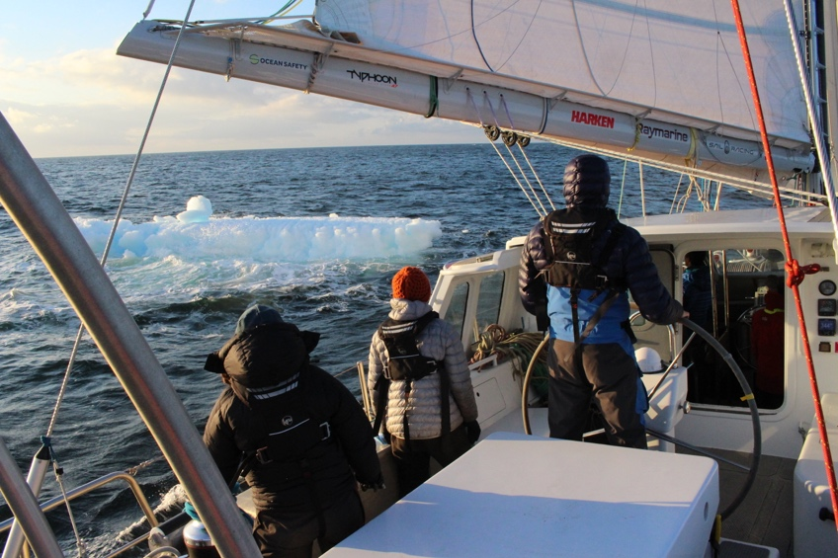

January 4th

That evening we ghosted past the north end of Saunders Island in a light westerly, through a band of ethereal shapes of bergs and bergy bits. We went slow in the oncoming darkness planning to dropping an anchor that night under radar in Cordelia Bay.

January 5th, 6th 7th

Mt Michael, the 1000m crater, had erupted in 2016 so this was of particular interest. Tom Hart had placed three camera penguin traps on the island during his last trip here in 2015. What those pictures would reveal would nail down the precise time of the eruption.

After a breakfast briefing, we inflated the Bombard C5 tender and made the first landing as a reconnaissance. Important to note that Thomas Geipel, a Pelagic veteran, did the tender driving for every landing, an important point of continuity. The swell was running, but not so much where we couldn’t drive the boat up the beach, turn it around and offload. We were all in our dry suits working in waste deep surf during these manuvers which required several trips to get equipment and everyone ashore.

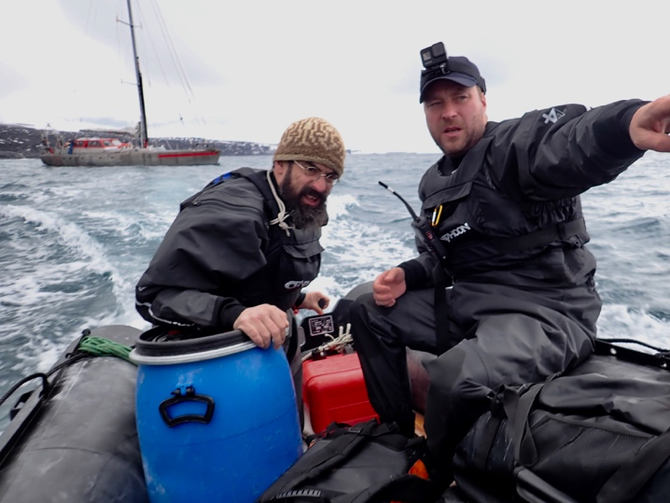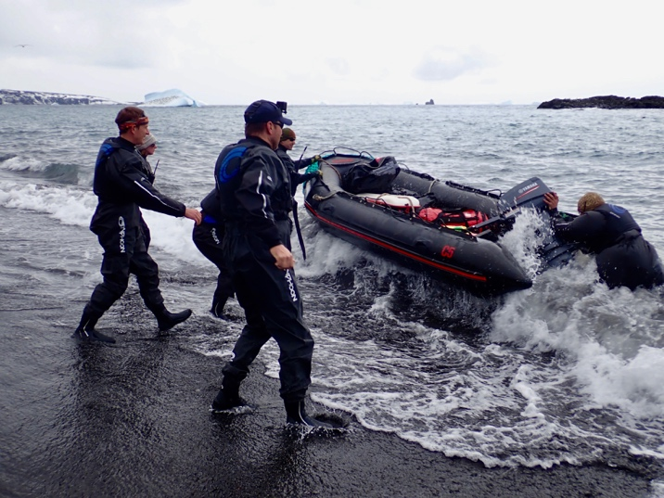
Landing in Cordelia Bay, Saunders Island

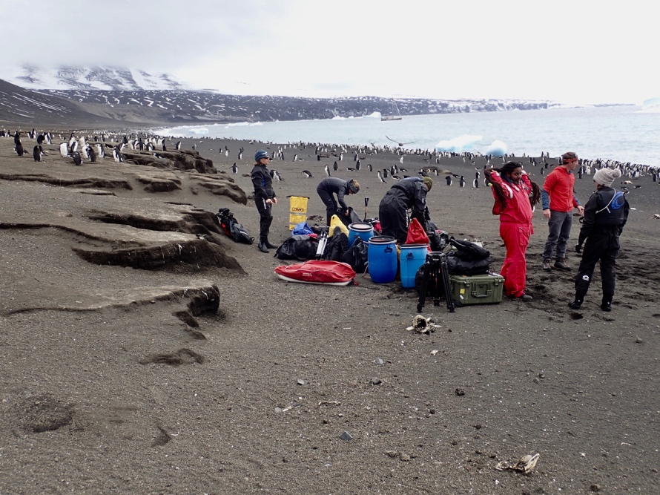

The weather was uncharacteristically stable for this region and we had a 10 hour day ashore. This was followed with similar conditions on January 6th and 7th. It was a bumper period for science and the only major disappointment was not getting Team Volcano up to the rim of the crater on Mt Michael. Although the weather was benign below about 500m, up top it was a raging gale and zero visibility on all three days. The presence of the lava lake remains a mystery.

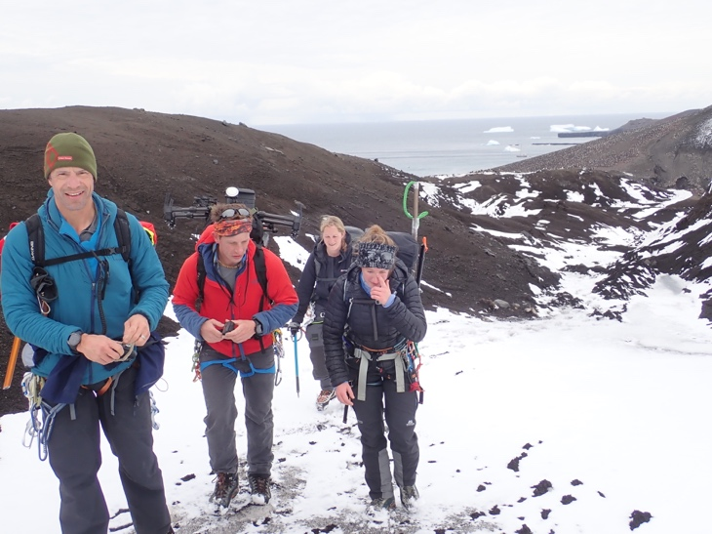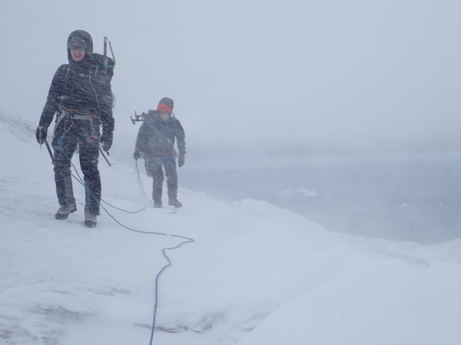
Attempt on Mt Michael

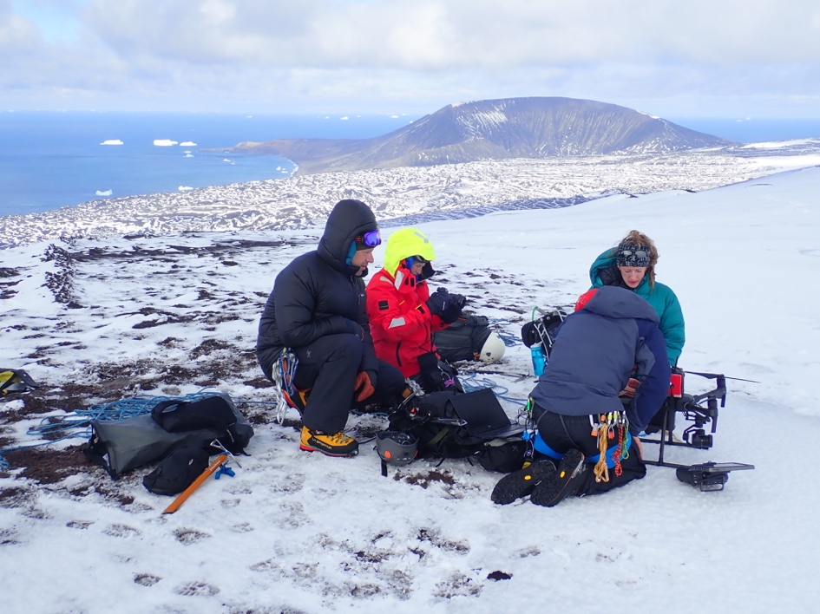
Gas sampling with the drone, Saunders Island

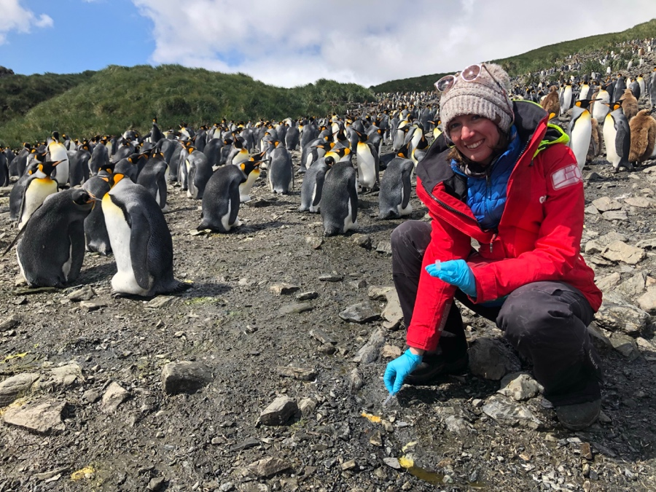
Gemma collecting the penguin poo

In the evening we raised anchor and sailed south for the South Thule Group.

January 8th

The day was spent at sea running down the 120nm miles to South Thule. South Thule is a group of three islands comprising Thule, Cook and Bellingshausen Islands. We anchored in the Maurice Channel between Bellingshausen and Cook Island late that evening, hoping to make a landing on Bellingshausen in the morning.

January 9th

As it turned out the surf was too ferocious to attempt a landing that morning so we took a rain check, intending to come back, and instead motored around south of Cook Island (one of the few islands that was not prioritized) to Ferguson Bay on the southeast corner of Thule Island, a distance of only 10nm.

This was our only ‘dry landing’ not needing dry suits. A convenient cove on the east side of Ferguson Bay was calm enough in the ongoing settled weather we have had for the last four days, so this made things easy. Everyone went ashore and took off in different directions. Hewison Point, a peninsula that strikes east from Ferguson Bay is the site of the Argentine military base Corbeta Uruguay that was established in 1976 and subsequently destroyed by the British military after the 1982 conflict. A mess of blown up pieces of metal, timber, wire and misc. debris, it is waiting for a proper clean up campaign. The penguins are nesting in amongst this mess and it is a very depressing site to behold.

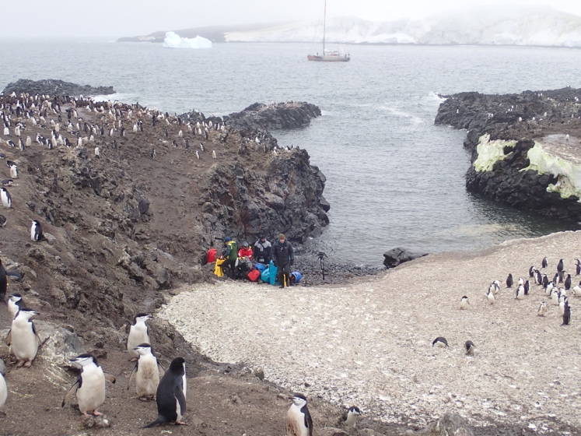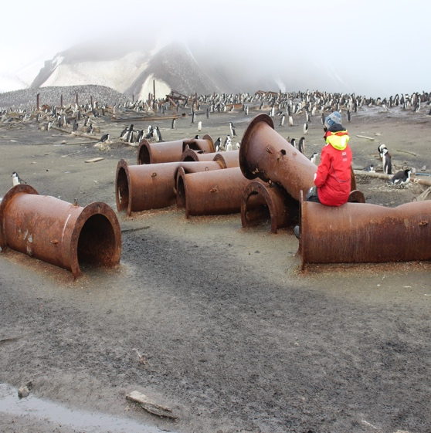

With all the teams accounted for and back on board (weather still holding!) we up anchored and motored through Douglas Strait that separates Thule and Cook Islands to Beach Point to census the penguin colony there by RPAS from the vessel. Instead of returning to the rolly anchorage or Ferguson Bay that evening we anchored on the northeast edge of Douglas Strait close to Cook Island with an even more rolly anchorage. We always had to hang on to our plates and glasses at dinner.

January 10th

Up early we motored around the north end of Cook Island and back into Maurice Channel for another go at landing on Bellingshausen. The landing Tom Hart did in 2015 was untenable with huge rollers cascading up the bouldery beach. We took the Bombard C5 in for a closer look to convince a few people, but it was a no go. We then went south around a headland and the surf here looked doable. Mario, Kieran and I jumped in and swam ashore and gave the thumbs up sign for Emma to bring out the equipment from the boat. Only four of us landed to keep things simple, while Tom flew the drones to census the penguin colonies on all sides of the island.

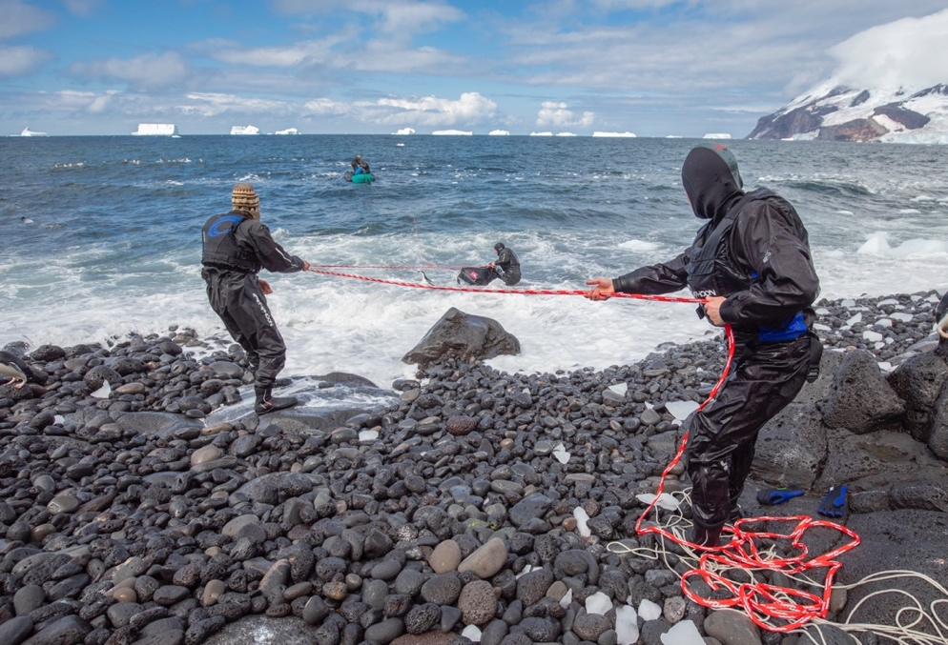
The floating line system

The four of us head a pleasant stroll up easy ground to the rim of the smoking crater at 260 meters. For the first time the sun was shining with a clear blue sky and little wind giving Team Volcano enough time and space to do their thing taking gas samples at the rim and down on the crater floor. Steam gushed out of the rim, hot enough to cook on. Moss beds proliferated in this warm, moist environment and the ground underfoot was soft and fragile.
Looking around the inside of the rim I could see white specs and if you kept looking you saw more and more of them – many hundreds at least. These were snow petrels, that characteristically nest very high up on cliff faces. They seemed to enjoy what was a sheltered arena with some warmth coming off the land. A short walk away we could get right next to several nests of these magnificent Southern Ocean seabirds. A rare privilege.

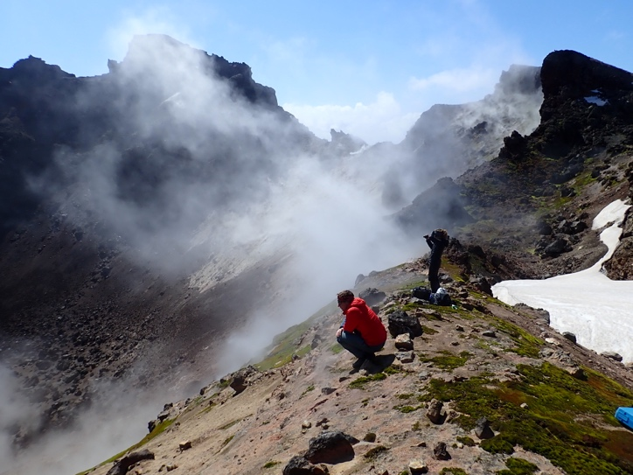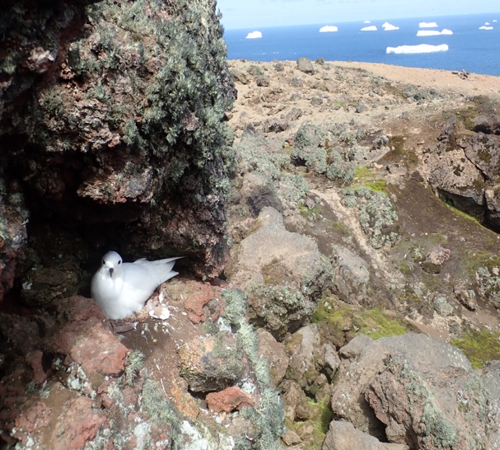

By mid afternoon we were back on the beach and towed out through the surf with our floating line system, which after some teething problems worked a treat, and made all these difficult landings possible and safe.

The 25nm run to Bristol Island was pleasant and we spent the remaining part of the day making successful drone flights over the penguin colonies on the outliers to the west of; Freezeland, Wilson and Grindle Rocks, plus Cape Turmoil on the main island. To be able to launch and recover these drones from the yacht was surely a game changer for Team Penguin. Job done. No reason to attempt a landing so we pushed onward towards Montagu Island.

Although Team Volcano were keen on grabbing some rock samples off the north side of Montagu, the swell was running and on dark, we thought better to sacrifice that one and make a beeline the 115nm past Saunders to Candlemas Island in view of a better chance of getting more people ashore.

January 11th

We dropped anchor in Kraken Cove on the north side of Candlemas mid morning. Kraken is more than a cove, and even more than a bay – it is enormous, open to the north and offers little protection from the swell which is always present on all sides of these tiny islands. With binoculars the surf looked substantial but you had to get right on the surf line to make a call. Tom, Ted, Kieran and me watched the surf from the Bombard, but probably not for long enough. Thomas drove the boat ashore and it was immediately flooded by the next breaker before we could turn the bow around. We offloaded the kit, bailed out and pushed him out with the backwash, but he was caught beam on and almost capsized. Only his aggressive driving skills and cool head saved the day. He made it back to Pelagic Australis safely while those of us on shore had a re-think. Clearly this was not the place to be. We decided to stumble over the beach boulders the kilometer away to Demon Point that marks the eastern side of the ‘cove’ making several trips to relay the stranding kits.

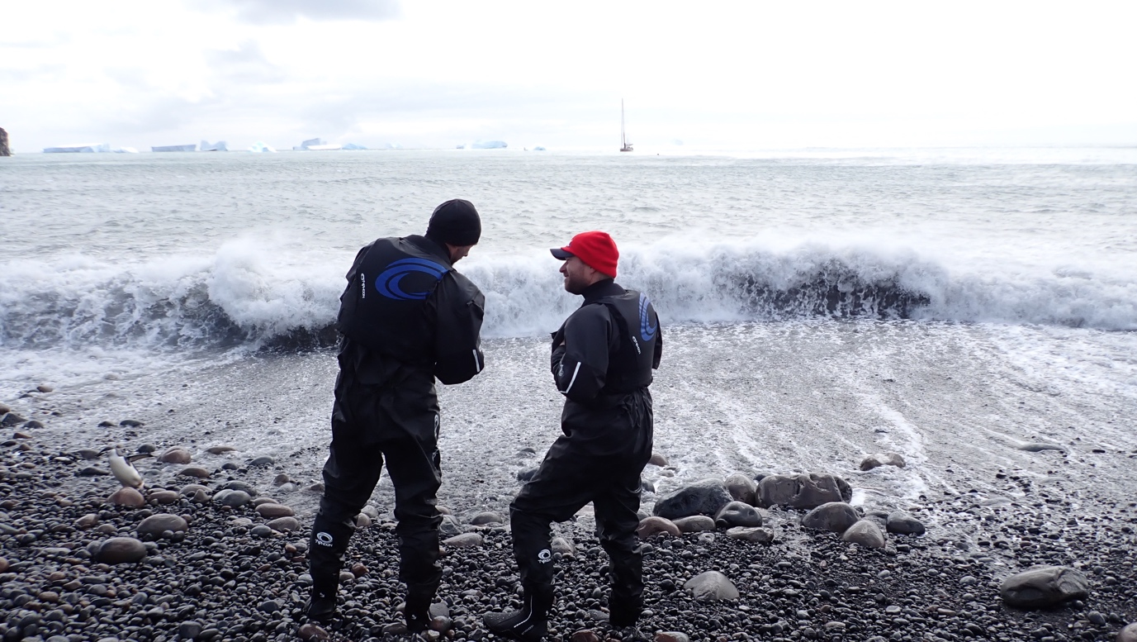
Having a re-think on the landing at Kraken Cove, Candlemas Island

The swell was ripping around the point there, but there was much more time between these sets and it appeared to be easing generally. By that time though it was late afternoon and we had to abort the landing, getting towed back out by Thomas.

January 12th

Second attempt landed Team Volcano, Mario from Team Ice, Ted and Skip while Tom and Gemma flew the drone from the vessel to take the penguin censuses.

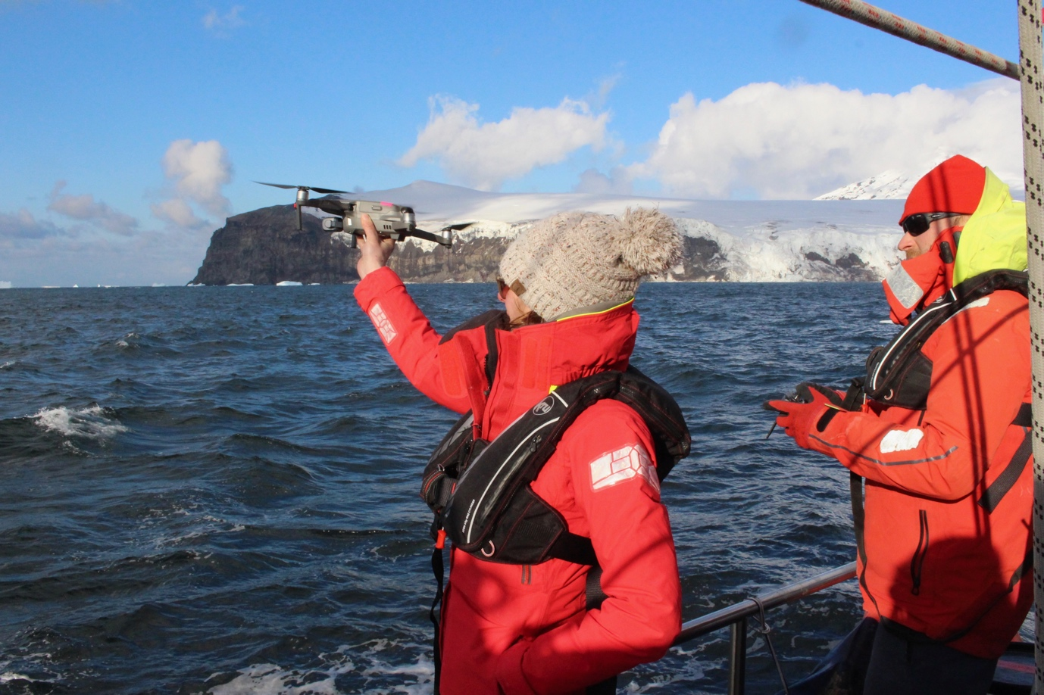

A long walk around the beach of Kraken Cove, then over some horrendously fragmented volcanic rock features aptly named the Breakbones Plateau brought us to Lucifer Hill for more volcanology, this time the rim of the crater was windy with almost zero visibility. Mario took snow samples on the way down and by mid afternoon we were back on board and up anchoring for the 55nm to Zavodovski Island, the jewel in the crown of the South Sandwich chain.

January 13th

Everyone wanted a piece of Zavodovski: Because of the eruptions in 2016 the fate of the 1.3 million pairs of Chinstrap penguins was unknown. The summit crater of Mt Curry was another smoking gem.

The problem though was this was to be the toughest landing. No beach but a slippery rock ledge on the east side, for which you had to jump for it at the top of the swell, on a high tide to boot.

We arrived early in predawn darkness and stood off the coast monitoring the radar. At daylight we found the landing, but the swell made even getting the Bombard C5 off the deck and over the side not really an option. Although disappointing, we were close enough along the shore to see the lower slopes carpeted in penguins, so it had to be assumed that the penguins had molted and returned to sea in time before the eruption. Tom and Gemma flew the drone on three flights and censused the entire island’s colonies – an incredible feat given the rough conditions for launch and more so for retrieval. We could not have done better. The accurate figures of how many penguins there actually are will be of prime importance for base line data going forward.

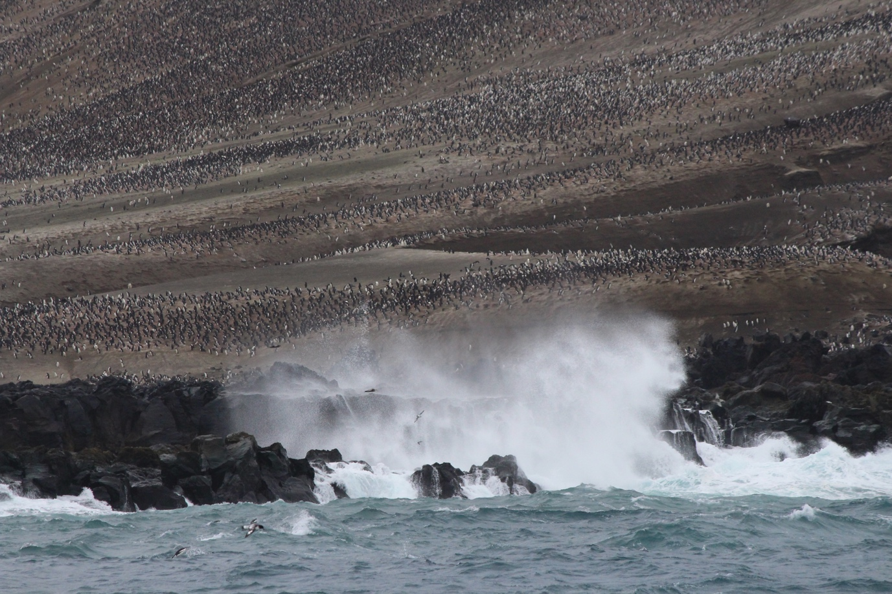
Millions of chinstraps and the wild coast of Zavodovski

ON TO THE TROPICAL PARADISE OF SOUTH GEORGIA

We had spent eight days within the South Sandwich chain. The question was whether to wait offshore off Zavodovski in hopes of making a landing, or count our chickens and take the weather window that was offered and high tail it the 300nm to Larsen Harbor for first shelter.

Taking a rough audit the science teams reckoned they had accomplished something on the order between 80 and 90% of their objectives on the South Sandwich. But there was more to do on the main island in the 10 days we had left to us before sailing back to Port Stanley.

In the relative shelter of the northwest coast of South Georgia, between January 14th and 25th here was our hit list accomplished:

- Drone census of the shag colonies on Clerke Rocks, a first.
- Ice coring on the snout of the Philippi Glacier in Larsen Harbour
- Taking DNA samples at the restricted Cooper Bay Macaroni colony, in hope of opening up that site.
- Drone censusing colonies at Cooper Bay
- Ice coring in Royal Bay
- Ice coring on the Szielasko Ice Cap, Barff Peninsula
- Drone census of the shag colony on the Shag Rocks, a first.

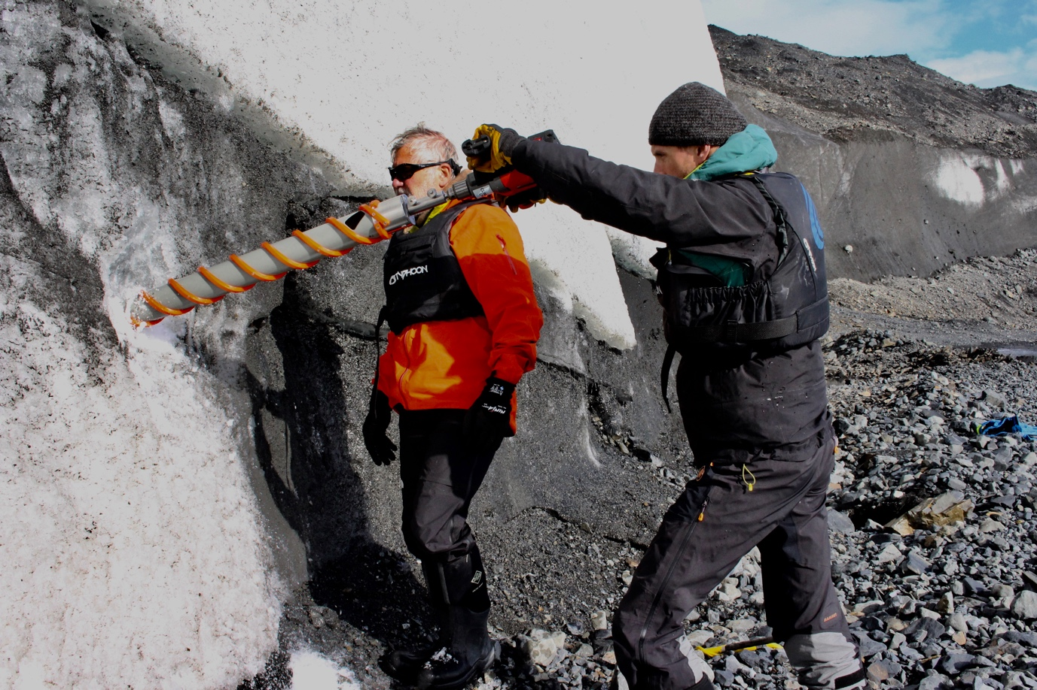
Professor Paul Mayewski and Mario drilling for ‘old ice,’ Royal Bay

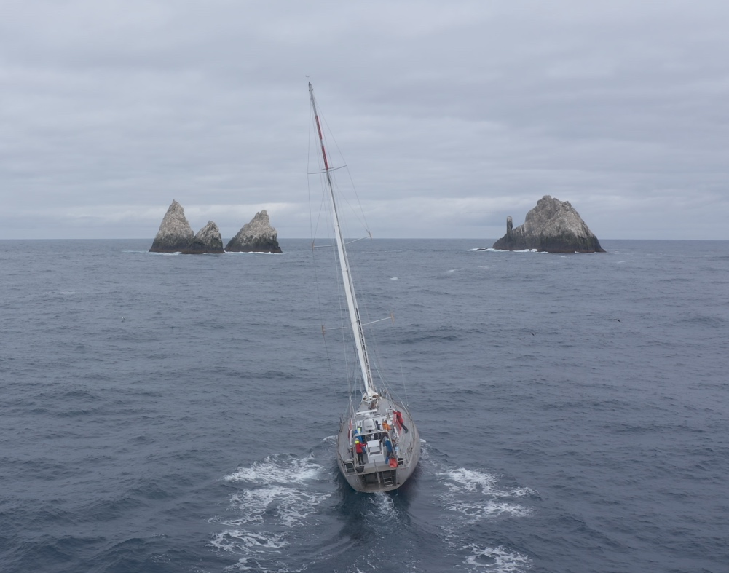
Pelagic Australis threading the needle in between the Shag Rocks for drone censusing

January 29th

Docked at the public jetty Port Stanley. Big night in the Vic on the cards.

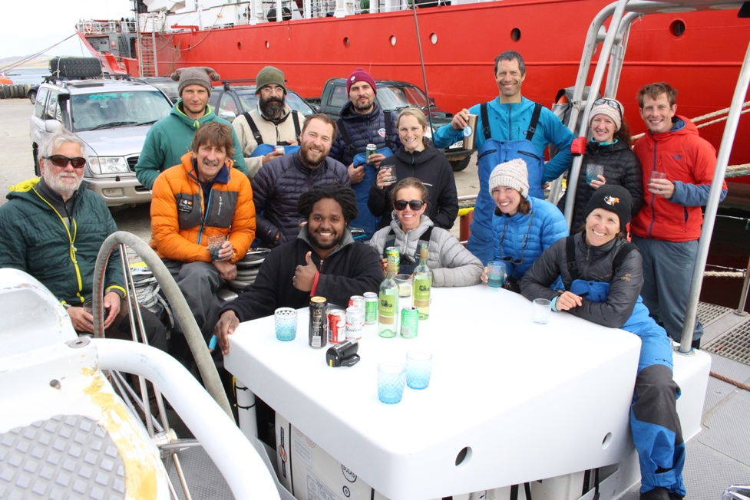

SAFETY PROCEDURES FOR ALL LANDINGS

- Emergency camping gear (one barrel and two dry bags with tents, food, fuel) for a party of ten were taken in on the first landing and taken off on the last trip back to the boat.

- Each shore team contingent had a small first aid kit.

- Each team had a marine VHF radio and we all checked in with the Expedition Leader Skip Novak on the hour, who was in touch with Captain Chris Kobusch and mate Sophie O’Neill on Pelagic Australis and Thomas Geipel in the Bombard C5 tender who were monitoring the weather and the swell at all the landings. VHF’s were always left on in case of a call to return to the landing.

- GRIB files were downloaded twice per day for anticipating any changes of weather.

- De-briefs were conducted in the evenings and plans formulated for the next day.

RECOMMENDATIONS FOR FUTURE TRIPS

Because of what must be considered to have been perfect weather conditions there was not a lot that went wrong. However, we were under no illusion that we had been extremely lucky and this must be in the forefront of anyone’s mind if trying to re-visit the South Sandwich. Our preoccupation of anticipating days spent at anchor unable to get ashore, or hove to offshore unable to anchor was not realised, but should not be ignored for any future expedition.

Because this was a multi-faceted science project, not least of all to generate funding, we could have been stretched too thin if the weather was typically bad. In future it is wise to concentrate on one island in the main to allow for bad weather days, and then have a back up plan as a second objective if weather and time allows.

EQUIPMENT

Tenders: Only fully inflatable tenders are suitable – not RIBS. We used a Bombard C5 which was big enough for the job with regards people and equipment, but light enough to easily manhandle on the beaches for landings. I would not recommend anything smaller. A Zodiac MK IV would be a bigger option (needing a bigger support vessel to carry it) , but I see no need to go any bigger than that.

Spare tender: Plus outboard. It is vital that a spare tender be ready to go if something happens to the primary boat. We did not have deck space to have our spare Bombard C4 tender inflated, but it was accessible and able to be inflated and deployed within a half hour by the three crew always left on board.

Dry suits: These are necessary for all people going ashore. We used Typhoon breathable dry suits with hoodies, booties and Typhoon PFD’s for all landings, except the one ‘dry’ landing on Thule. Barrels and drybags were brought ashore with outer clothing to be changed into on the beach, and the dry suits put in barrels for protection during the time ashore.

Tender to shore line system: This was an experiment that after a few false starts worked very well. There were no sandy beaches whatsoever, rather all shorelines consisted of medium to large rocks and boulders, steep and slippery. Not only was there a risk of capsizing the dinghy in the surf (present on all beaches except the cove on Thule), but the chance of blowing off an outboard prop on the rocks is high. By keeping the tender beyond the breaking surf, not much can happen, at least to the tender.

Method: One person, better two, has to swim ashore. The bowman in the dinghy then throws in a heaving line to the shore person. After experimenting with a monkey’s fist, we eventually used an empty plastic yellow flare box. This was easier to launch and it floats, so the shore man can wade in to grab it. Attached to that leader (3 or 4mm cord, 25m) were two full length polypropylene ski tow ropes lashed together and with a large s/s clip at the junction. The other end was a 10mm yacht rope 30m. All of these lines (prone to tangling) have to kept flaked into a large bucket with the end tied to the bucket – not to the tender! Once the line system was ready between the shore man and the tender, gear bags/barrels with or without a person hanging on were attached to the big clip and this was pulled in from the shore and let out from the dinghy. The key was to make all the lengths longer than you think necessary, as often the tender would have to reverse out sharply to avoid a breaker and you must have that slack in the system. Well set up, it was very quick and efficient to evacuate the beach of people and gear.

THE TEAM

Name | Title | Nationality
Dr. Tom Hart | Co-Expedition Leader, Science Coordinator, Penguinologist / Drone Operator Specialist, Research Fellow, Department of Zoology, Oxford University | British
Skip Novak  Skip Novak | Co-Expedition Leader | American
Dr. Gemma Clucas | Penguinologist, Postdoctoral Fellow, Cornell Lab of Ornithology | British
Dr. Emma Liu | Volcanologist, Lecturer in Volcanology, University College London | British
Dr. Kieran Wood | Volcanology Technical Engineer / Drone Operator Specialist, Senior Research Associate, Advanced Aerial Resources, University of Bristol | British
Dr. Paul Mayewski | Glaciologist / Climate Scientist, Director of the Climate Change Institute, University of Maine | American
Mariusz Potocki | Glaciologist / Climate Scientist, PhD Student/ Research Assistant, Department of Earth Sciences, University of Maine | Polish
Ted Cheeseman | Whale Biologist, PhD Candidate, Southern Cross University New South Wales, Australia | American
Ruth Peacey | Film Maker, Director and Producer | British
Hamza Yassin | Cameraman/ Drone Operator Specialist | British
Dr. Jo Feldman | Expedition Physician | American
Chris Kobusch | Skipper | German
Sophie O’Neill | Mate | British
Thomas Geipel | Crew, tender driver | German

Skip Novak and Tom Hart
May 20th 2020

