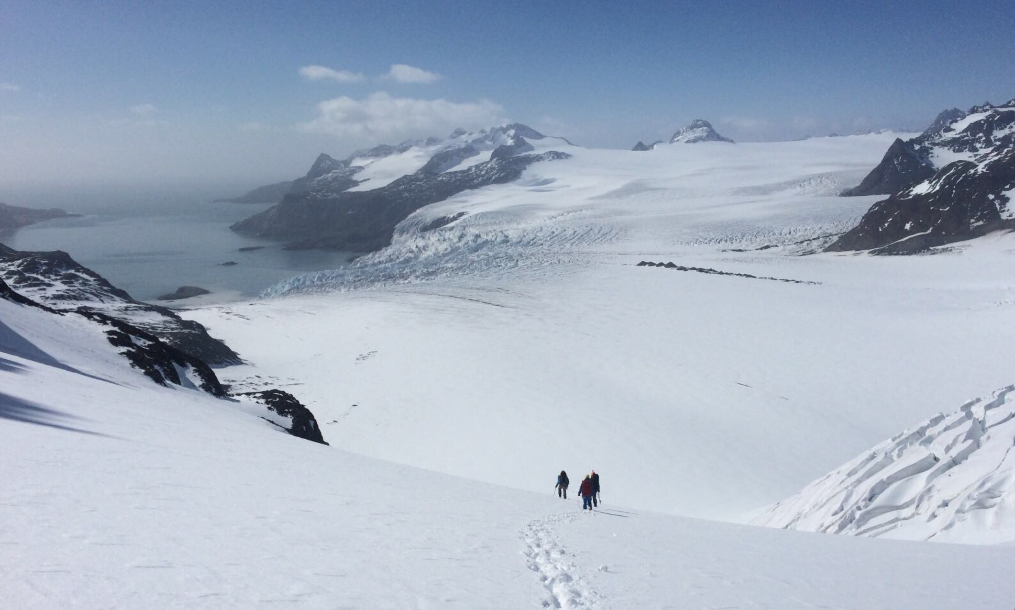
EXPEDITION REPORT
SHACKLETON CROSSING - MARCH 2017
AURORA EXPEDITIONS

EXPEDITION REPORT: AURORA EXPEDITIONS - ASG69 MARCH ‘17
GUIDES : Phil Penney Anna Keeling
CLIMBERS : Peg Flick (USA) Eamonn Stapleton (UK) Sheona York (UK) Tatsunosuke Ikawi (JAPAN) Glen Haifer (AUS) (Glen on select trips where climber numbers are noted as 5)
EXPEDITION : The completion of the South Georgia crossing from King Haakon bay to Stromness Harbour. Approx 40km, first completed by Shacklton, Crean and Worsley in 1916.
DAY 1 08/03 : Meet and greet Polar Pioneer. Equipment checks, boat drills. Set sail down Beagle Channel for the Antartic Peninsular.
DAY 2 & 3 09,10/03: Drake passage. Prepare for peninsular climbing. Fast easy crossing in Benign weather. Late evening landing at Aitcho islands, South Shetland group.
DAY 4 11/03 : Half moon Bay, Livingston Island. Climb one of two peaks, 450m approx. on the main spine of Livingstone Island. Named the Bishops for the mitre look about them and want of a better name. Mostly glacier travel with a bit of excitement up the top involving a rope pitch to the summit. Great views and a taste of things to come. (5 climbers )
Deception Island was our second landing for the day. We hiked up Ronald Hill and did self arrest practice in the snow beyond. (4 climbers)
DAY 5 12/03 : Sea ice rendered the Weddel Sea unapproachable so we sailed south, Through the Gerlache Strait to Paradise Bay. Climbed an unnamed peak on Bryde Island, apporx 450m, with steep glacier travel leading to an exposed ridge and a pitch to the summit. Big cornices at the top.( 5 climbers )
We landed on the continent at the Argentinian run base, Ameranty Brown, Paradise bay. Followed by some of us jumping over the side for a polar plunge.
The afternoons landing was on Ronge Island in the Errea channel. Our party climbed Ronge Tower on the SW courner of the island. Some steep travel was required to get off the coast finishing with an exposed summit ridge. Spectacular weather, views and day. (4 climbers)
DAY 6 13/03 : Trinity Island. Poor weather with showers and gale NE winds. Our party cramponed up the SE head of Mikkelsen Harbour, followed by some ice climbing on steep sea cliffs. (5 climbers)
The afternoon landing was in Curtis Bay and a climb of Phil’s Knob. This short climb offered excellent views of the surrounding bay. (4 climbers)
DAYS 7, 8, 9 14,15,16/03 : The Scotia sea. Viewed Elephant island and Wild point where Shackltons men survived for several months, then sailed on to King Haakon bay, South Georgia.
DAY 10 17/03: King Haakon bay. Gale SE required us to delay the departure for the South Georgia crossing. Our party cramponed up to the Shacklton gap, a broad saddle separating King Haakon bay from Possession Bay. (4 climbers)
The afternoon was spent Sailing to Possession Bay.
DAYS 11 & 12 18,19/03: The Crossing ! Great weather, we set out early toward Shacklton Gap from Possession bay toward the Tridents, an alpine pass separating major glacial systems. Good cramponing conditions and fast travel. The route through the Trident pass was straight forward and we were on the Crean glacier and Crean camp by midday. The rest of the afternoon was consumed by the long 10km march up the Crean glacier. We camped at the foot of a mountain buttress about a kilometre SW of the Nunatak. Stunning views and sunset.
The morning of Day two was cold and overcast with the higher summits under cloud. The decent took us down the Fortuna glacier and through the glacial ‘pinch’ to Fortuna Bay. Had a nice wildlife experience with fur seals, elephant seals, giant petrels, and king penguins while we waited for the ship. (4 climbers)
That afternoon we completed the crossing by walking over the hill from Fortuna to Stromness bay with most of the ships company.
DAY 13 20/03 : The morning, Hercules Bay. Zodiac cruise. Macaroni Penguins.
The afternoon landing, Grytviken, Shackltons grave, whaling station, history museum.
DAY 14 21/03 : Gold Harbour. Wild life central. Elephant seals, huge King penguin colony. All the climbers walked up the north eastern head of the harbour for a great over view of the area.
Ocean Harbour was the afternoon landing., with a ship wreak and wildlife. The climbing team walked back toward the saddle at the head of the bay. That evening we said goodbye to South Georgia and started sailing north.
DAY 15,16,17 22,23,24/03 : At sea. Destination Faukland islands and onward travel plans.

Client screening:
The clients for the SG crossing were all capable of the trip. For the most part, the equipment clients brought along was excellent and a thorough gear check was undertaken early in the voyage. We provided ice axes and helmits for two clients and several sets of prussick loops.

We were able to get several training sessions on the Antarctic Peninsula for a climbing practice (as described above), and also covered glacier travel, self arrests, crevasse rescue and emergency procedures. Tents were erected on the ship’s back deck as a training exercise. One client ( Glen ) joined us on the climbing portion on the Antarctic Peninsula but did not join us on the S G Crossing due to a recent injury. He joined us again for the trip from Fortuna to Stromness.
Vetting client applications remains crucial in the success of this expedition. The process for this year’s crossing included a personal phone call between the Technical Adviser and applicants. This helped ensure that experience and currency on resumes were valid.

Cooking /Food:
Enough food was packed for four days as per the permit requirements. This included dehydrated meals brought from New Zealand by NZ lead guide, Phil Penney, for all participants for all meals.. Muesli, Cheese, crackers and snack food were taken from the ship with power bars purchased in New Zealand, and chocolate bars from the ship.

Navigation:
We used the 1:100,000 BAS Map - NZTM Zone 24 with Magnetic declination of seven degrees. A private Garmin GPS marked with all the crossing waypoints was carried. An Inreach device was carried allowing email and SMS communication via a paired Bluetooth phone . An Iphone was loaded with Gaia mapping software. Also carried were plastic printouts combining Google Earth with a Gaia topographic overlay at a scale of approximately 1:25,000 with the way points graphed on them. One map was carried on the traverse and the other was posted on the office whiteboard with GPS coordinates for all waypoints.
Finally, a satellite telephone was included in the party safety equipment.

Emergency Procedures:
An updated emergency contingency procedure was discussed with the Expedition Leader. However the expedition team carried sufficient equipment to sit out poor weather and self rescue an injured party member.

Weather information

Weather information was being sent daily from a guide in New Zealand. The Metvuw.com forecasting website provided accurate timings on the passage of the cold fronts and forecasted the clearance accurately. This made planning for a alternate start at Possession Bay a more streamlined call as the weather models proved to be fairly accurate.

This was supplemented by the Grib files available on the ship.
Insurance:
All participants should have a rescue and evacuation insurance. All policies were checked by the Aurora office. Medical forms and indemnity forms for all participants were checked at our initial briefing on board.

